Republic of Iraq
Ministry of Higher Education and Scientific Research
University of Baghdad
College of Medicine
Department of Family and Community Medicine



Depression among Medical Students
at University of Baghdad,
College of Medicine
A research project submitted to the Department of Family and Community Medicine, College of Medicine, University of Baghdad, in partial fulfillment of the requirements of the Research Project module (RP-2).

Prepared by:
Abha Shaker Kadhim
Allia Mayas Abdul Sattar
Ghadeer Ali Kadhim

Supervised by:
Assist. Prof. Dr. Eman Adnan Al-Kaseer
Academic Year 2026 – 2027

ACKNOWLEDGMENT
We express our deepest gratitude to our supervisor, Assist. Prof. Dr. Eman Adnan Al-Kaseer, for her continuous guidance, scientific advice and encouragement throughout this project. We are thankful to the Dean and the staff of the Department of Family and Community Medicine, College of Medicine, University of Baghdad, for their cooperation and for allowing us to conduct this study in their institutions. We also sincerely thank all the medical students who took the time to complete the questionnaire; their willingness made this research possible. Finally, we thank our families and friends for their patience and support.

LIST OF ABBREVIATIONS
Abbreviation | Meaning
CI | Confidence interval
DSM | Diagnostic and Statistical Manual of Mental Disorders
EPV | Events (outcomes) per variable
GPA | Grade point average
HADS | Hospital Anxiety and Depression Scale
IQR | Interquartile range
OR | Odds ratio
PHQ-9 | Patient Health Questionnaire-9
SPSS | Statistical Package for the Social Sciences
VIF | Variance inflation factor
WHO | World Health Organization

LIST OF TABLES
Table 1. Data quality overview of the study dataset.
Table 2. Missing data per variable.
Table 3. Distribution diagnostics for the PHQ-9 total score.
Table 4. Socio-demographic characteristics of the sample (n = 149).
Table 5. Clinical and academic characteristics of the sample.
Table 6. Item-level descriptive statistics for the PHQ-9 (0-3 scale).
Table 7. Distribution of PHQ-9 severity categories and cut-point prevalence.
Table 8. Prevalence of PHQ-9 score ≥ 10 by academic stage.
Table 9. Univariate association of categorical covariates with PHQ-9 score ≥ 10.
Table 10. Multivariable binary logistic regression for PHQ-9 score ≥ 10 (primary model: covariates selected by the univariate screen).
Table 11. Ancillary logistic model additionally including the mood-impact item.
Table 12. PHQ-9 total score by academic stage, with the Kruskal-Wallis comparison reported in the text.
Table 13. Spearman rank correlation of ordinal variables with the PHQ-9 total score.
Table 14. Association of academic-performance variables with PHQ-9 status (≥ 10).
Table 15. Kruskal-Wallis comparison of PHQ-9 scores across academic-performance groups.
Table A1. Variable dictionary (30 variables).
Table B1. Statistical tests and their assumptions.

LIST OF FIGURES
Figure 1. Distribution of PHQ-9 total scores (histogram, 2-point bins) across the 147 participants eligible under the scoring rule.
Figure 2. Distribution of PHQ-9 severity categories among the 147 participants eligible under the scoring rule.
Figure 3. Prevalence of moderate-or-higher depressive symptoms (PHQ-9 ≥ 10) by academic stage.
Figure 4. PHQ-9 total score by self-reported mood-impact frequency; Kruskal-Wallis H = 58.91, df = 3, p < 0.001.
Figure 5. PHQ-9 total score by self-reported income sufficiency (n = 138; Kruskal-Wallis p = 0.003).
Figure 6. Box plot of PHQ-9 total score by sex (n = 147 analysed: 107 female, 40 male).
Figure 7. Box plot of PHQ-9 total score by academic stage.
Figure 8. Scatter plot of age versus PHQ-9 total score (Pearson r = -0.032, p = 0.70, n = 147).
Figure 9. Inter-item correlation matrix (items 1 to 9).

ABSTRACT
This cross-sectional study recruited a convenience sample of 150 medical students at the College of Medicine, University of Baghdad (2025-2026). An anonymous online questionnaire (Google Forms) recorded socio-demographic, clinical and academic items together with the 9-item Patient Health Questionnaire (PHQ-9). The primary outcome was a PHQ-9 total score of 10 or higher (screen-positive status). One of the 150 collected responses was excluded as an implausible data-entry error, leaving 149 students (72.5% female; mean age 21.1 years); the mean PHQ-9 score was 11.12 (SD 7.03) among the 147 participants eligible under the missing-item rule, and 78 of these 147 (53.1%; 95% CI 45.0-60.9) reached the moderate-or-higher threshold. Prevalence was numerically highest in the third academic stage (69.0%), although the difference across stages was not statistically significant, and 33 students (22.1%) endorsed the self-harm item (24.6% of the 134 who answered it). In the primary multivariable model (income and chronic disease), chronic physical illness showed an exploratory association with depressive symptoms (OR 5.38, 95% CI 1.48-19.56, p = 0.011) that did not survive multiplicity correction, and income was not significant; the mood-impact item was also strongly associated (OR 4.39, 95% CI 2.41-7.98, p < 0.001) but overlaps the outcome construct. No significant association between PHQ-9 screen-positive status and academic performance was found in this sample. These findings indicate a high burden of depressive symptoms among medical students in our setting and support routine screening with accessible counselling.
Keywords: depressive symptoms; PHQ-9; medical students; University of Baghdad; cross-sectional study; mental health screening; academic stress
TABLE OF CONTENTS
ACKNOWLEDGMENT I
LIST OF ABBREVIATIONS I
LIST OF TABLES I
LIST OF FIGURES I
ABSTRACT I
CHAPTER ONE: INTRODUCTION 1
1.1 Background 1
1.2 Medical students as a high-risk group 1
1.3 Local evidence and the research gap 1
1.4 The screening instrument 1
1.5 Aim and objectives 1
CHAPTER TWO: LITERATURE REVIEW 1
2.1 Global burden of depression among medical students 1
2.2 The PHQ-9 as a screening instrument 1
2.3 Evidence from the Middle East and Iraq 1
2.4 Depression and academic performance 1
CHAPTER THREE: MATERIALS AND METHODS 1
3.1 Study design and setting 1
3.2 Participants and sampling 1
3.3 Data collection tool 1
3.4 Ethical considerations 1
3.5 Definitions 1
3.6 Statistical analysis 1
CHAPTER FOUR: RESULTS 1
4.1 Introduction 1
4.2 Data Quality and Assumption Checks 1
4.3 Sample Characteristics 1
4.4 Prevalence of Depressive Symptoms (Objectives 1 and 2) 1
4.5 Factors Associated with Depression (Objective 3) 1
4.6 Impact of Depression on Academic Performance (Objective 4) 1
4.7 Limitations of the Analysis 1
CHAPTER FIVE: DISCUSSION 1
CHAPTER SIX: CONCLUSIONS AND RECOMMENDATIONS 1
Conclusions 1
Recommendations 1
REFERENCES 1
Appendix A. Variable Dictionary 1
Appendix B. Statistical Methods and Assumptions 1
Appendix C. Study Questionnaire 1

Note: This Table of Contents is generated via field codes. To ensure page number accuracy after editing, please right-click the TOC and select “Update Field.”

CHAPTER ONE: INTRODUCTION

1.1 Background
Depression (depressive disorder) is one of the most common mental disorders in the world. According to the World Health Organization, an estimated 322 million people were living with depression in 2023, including 5.2% of the adult population [1]. The disorder is characterised by persistent sadness, loss of interest or pleasure, sleep disturbance, fatigue and impaired concentration, and it is a leading cause of disability worldwide. Although depression is treatable, a large proportion of affected individuals do not receive timely care, and the disorder therefore carries a substantial human and societal burden.

1.2 Medical students as a high-risk group
Medical students are a population of special concern. The medical curriculum combines a large academic load, frequent high-stakes examinations, long study hours, an early transition into stressful clinical environments, and exposure to serious illness and death. These demands, together with social and personal pressures, make medical students particularly vulnerable to psychological distress. Large-scale reviews support this concern: two systematic reviews, together covering more than 190,000 students worldwide, report that roughly one in four medical students screens positive for depression and that only a minority of those affected seek professional help [3]. The individual estimates are given in Chapter Two (Section 2.1).
The consequences of untreated depression extend beyond the students themselves. Depressive symptoms are associated with poor academic performance, impaired concentration, reduced motivation and diminished overall well-being [1,4]. If not recognised and addressed, psychological distress during medical training may persist into early professional life, affecting the quality of patient care and increasing the risk of burnout among future physicians [5]. Systematic reviews of burnout among medical students document a substantial burden, with reported prevalence of 7.0-75.2% depending on country and instrument, and call for context-specific prevention strategies [5].
Help is rarely sought. Frequently reported barriers include the time cost of counselling, the fear of being perceived as weak or as a risk to clinical career prospects, and the cultural stigma attached to psychiatric illness, which together compound the gap between the need for care and the care that is sought. Each of these factors argues for screening-based detection combined with an on-campus referral pathway, rather than waiting for students to present for care on their own.

1.3 Local evidence and the research gap
For the College of Medicine of the University of Baghdad specifically, the most recent published evidence is a PHQ-9-based survey published in 2021 [6]; no study has documented the current prevalence or the associated factors in the 2025-2026 cohort, which has experienced a different academic and social environment since that survey. This study was therefore designed to update the evidence base for our own institution, to identify the socio-demographic, clinical and academic factors associated with the highest risk, and to generate the concrete data that a college-wide screening-and-referral policy needs before it can be considered by the college administration and the Ministry of Higher Education.
In the Middle East and in Iraq the burden also appears to be high: regional surveys and a study conducted at our own college report that roughly half of the medical students screened had depressive symptoms [6-9]. These studies are reviewed in detail, with their individual estimates and thresholds, in Section 2.3. Despite these data, there is little recent evidence on the current prevalence and the associated factors among medical students at the University of Baghdad in the 2025-2026 academic year.

1.4 The screening instrument
The Patient Health Questionnaire-9 (PHQ-9) is the most widely used depression screening instrument. It comprises the nine DSM criteria for major depression, each scored 0 (not at all) to 3 (nearly every day), giving a total score of 0-27, with 0-4 minimal, 5-9 mild, 10-14 moderate, 15-19 moderately severe and 20-27 severe [10-11]. In an updated individual-participant-data meta-analysis of 100 studies comprising 44,503 participants, the standard cut-off of 10 or higher achieved a pooled sensitivity and specificity of 0.85 for major depression, which supports its use as a screening and severity measure in research and primary care settings [10].

1.5 Aim and objectives
In light of the high reported prevalence of depressive symptoms among medical students in the Middle East and Iraq, and the limited recent data from our institution, this study was undertaken to determine the current prevalence of depressive symptoms among medical students at the College of Medicine, University of Baghdad (2025-2026), to assess it with the validated PHQ-9 screening tool, to identify the factors associated with depressive symptoms in this population, and to assess the association between screen-positive PHQ-9 status and self-reported academic performance (cross-sectional design; no causal inference).
The study addressed four objectives: (1) to estimate the prevalence of moderate-or-higher depressive symptoms (PHQ-9 score of 10 or higher) among medical students at the College of Medicine, University of Baghdad; (2) to describe the distribution of PHQ-9 severity bands in the same sample; (3) to identify the socio-demographic, clinical and academic factors associated with screen-positive status; and (4) to assess the association between screen-positive status and academic performance.

CHAPTER TWO: LITERATURE REVIEW

2.1 Global burden of depression among medical students
Two large meta-analyses published in 2016 established the current global picture. Puthran and colleagues pooled 77 studies (62,728 medical students and 1,845 non-medical students) and found a global prevalence of 28.0% (95% CI 24.2-32.1%); prevalence was highest in the first year of study and decreased progressively across the curriculum, and Middle Eastern medical students were more likely to be depressed, although this between-region difference did not reach statistical significance [2]. Rotenstein and colleagues, in a complementary review of 195 studies in 47 countries, estimated a pooled prevalence of depression or depressive symptoms of 27.2% (95% CI 24.7-29.9%) and a pooled prevalence of suicidal ideation of 11.1% (95% CI 9.0-13.7%); among students screening positive, only 15.7% sought psychiatric treatment [3]. The two estimates are broadly consistent and, taken together, indicate that roughly one in four medical students worldwide screens positive for depression, a figure substantially above that of the general population.

2.2 The PHQ-9 as a screening instrument
The PHQ-9 was developed from the DSM criteria for major depression and has become the de facto international screening tool in research and primary care. In the updated individual-participant-data meta-analysis by Negeri and colleagues [10], pooled sensitivity and specificity at the standard cut-off of 10 or higher were both 0.85 (95% CI 0.79-0.89 and 0.82-0.87, respectively), and accuracy varied modestly with the reference diagnostic interview used [10]. The instrument is brief, self-administered, free of licensing restrictions and suitable for large student samples, which is why it was selected for this study. An Arabic translation of the PHQ-9 has been validated in an Arabic-speaking university sample (731 students, mean age 21.3 years), with good internal consistency for the nine items (Cronbach's alpha 0.86) [12].

2.3 Evidence from the Middle East and Iraq
Regional evidence is consistent with a higher-than-average burden. In Egypt, 65% of 700 medical students at Assiut University showed depressive symptoms on the DASS-21, with female sex, on-campus residence, preclinical stage and lower academic achievement all associated with higher scores [7]. In Saudi Arabia, a systematic review of 18 studies reported a mean prevalence of 51.5% (range 30.9-77.6%), with moderate-to-severe depression more common than mild symptoms, and females, first-year students and smokers at higher risk [8]. In Iraq, 45.9% of 750 pharmacy and medical students across four Baghdad universities screened positive for depression on the HADS [9], and a PHQ-9-based study at the College of Medicine, University of Baghdad, reported that 57.9% of 323 students had mild-to-moderate symptoms (a lower symptom threshold than the ≥ 10 cut-off used in the present study), significantly associated with gender, the presence of a medical condition, family problems, communication difficulties and stressful life events, but not with age, marital status, academic year or part-time employment [6]. Two further Iraqi studies extend this picture beyond single colleges. A nationwide cross-sectional survey conducted between July 2024 and February 2025 (3,107 adults, PHQ-9) found severe depressive symptoms in 20.4% of the sample, with higher levels in the middle and southern provinces and in younger adults aged 18-35 years [13]. A separate 2024 survey of 1,725 Iraqi medical students using the Beck Depression Inventory reported that depressive symptoms were common and more frequent among women [14]. Taken together, these data indicate that the burden is not confined to one college or one governorate, but they also show that no recent study has measured the current prevalence or its correlates among medical students at our own institution with the PHQ-9, which is the gap this research addresses.

2.4 Depression and academic performance
The relationship between depressive symptoms and academic outcomes is biologically plausible (impaired concentration, fatigue and loss of motivation) and has been examined in numerous studies. A 2026 systematic review of 45 studies found that stress, anxiety and depressive symptoms showed predominantly negative associations with academic performance in 67-80% of the included articles, while intrinsic motivation, resilience and perceived social support showed predominantly positive associations; the authors caution that the predominance of cross-sectional designs and heterogeneous outcome measures precludes causal inference [4]. Null findings are also reported, so the association varies between settings. Because academic performance was one of the stated objectives of this study, the association between PHQ-9 status and grades, self-rated performance and history of failing or repeating was examined directly (Chapter Four, Section 4.6).

CHAPTER THREE: MATERIALS AND METHODS

3.1 Study design and setting
A cross-sectional study with an analytic element was conducted at the College of Medicine, University of Baghdad, during the 2025-2026 academic year, as a Research Project-1 (RP-1) module study. The design was chosen because the objectives require measurement of prevalence and its associations at a single time point.

3.2 Participants and sampling
Medical students of all six academic stages attending the College of Medicine, University of Baghdad, who agreed to participate were eligible. A convenience sample of 150 completed responses was obtained; one record (a self-reported age of 62 years, implausible for this student population) was excluded as a data-entry error, leaving 149 participants for analysis. The sample size was calculated using Cochran's formula for a single proportion, n = Z² p (1−p) / d², with Z = 1.96 (95% confidence), p = 0.5 (maximum variability) and d = 0.08, giving 150.06 and hence a target of 150 students; this margin of error corresponds to a precision of about ±8 percentage points at a prevalence near 50%, which is the precision the reported 95% confidence intervals actually achieved.

3.3 Data collection tool
A structured questionnaire was used, comprising three parts (reproduced in full in Appendix C). The first part collected socio-demographic information (age, gender, academic stage, marital status, residence, family income, smoking and chronic disease). The second part collected habits and academic-status variables (previous psychiatric diagnosis or psychiatric medication, average daily sleep duration, daily self-study hours outside the college, support from family and friends, overall grade of the last academic year, history of failure or of repeating a year, self-rated performance compared with previous years, and whether mood affects study, attendance or examinations). The final section comprised the PHQ-9, in which nine items, each corresponding to one DSM criterion for major depression, are rated from 0 (not at all) to 3 (nearly every day), giving a total of 0-27; scores of 0-4, 5-9, 10-14, 15-19 and 20-27 denote minimal, mild, moderate, moderately severe and severe depression, respectively [10-11]. A total score of 10 or higher was taken as the primary threshold for the presence of moderate-or-higher depressive symptoms. The ninth item addresses self-harm; any student endorsing this item was encouraged to seek help from the college counselling services.
The questionnaire was an anonymous online form (Google Forms) administered in Arabic; the link was distributed to the six class groups of the college, and participation was voluntary and anonymous. The nine PHQ-9 items were presented bilingually (Arabic and English); the Arabic wording was a concise rendering of the original items, and the recall window (the past two weeks), the four-point response scale (0-3) and the original item order were retained. Internal consistency in the present sample was high (Cronbach's alpha 0.88; see Chapter Four), comparable to the value reported for the validated Arabic version of the instrument (0.86) [12]. The questionnaire used in this study is reproduced in full in Appendix C. Data were collected during the 2025-2026 academic year. Because the link was distributed through class groups, the exact number of students who received it is not known, so a conventional response rate cannot be calculated; 150 completed responses were received; 149 were retained for analysis after one implausible record (data-entry error) was excluded.

3.4 Ethical considerations
Informed consent was obtained through a consent statement at the beginning of the online form, which had to be accepted before the questionnaire could be completed; all 150 respondents gave consent. Participation was voluntary and anonymous, no identifying information was collected, and the questionnaire was completed independently by the students. The study was conducted as part of the Research Project-1 (RP-1) module of the College of Medicine, University of Baghdad. The study required no separate ethics-committee approval number: as an anonymous, non-interventional questionnaire survey it was exempt under the module's procedures. No therapeutic intervention was provided as part of the study; students who screened positive were informed of the available counselling resources. Because the survey was anonymous, students who endorsed the self-harm item could not be identified individually; as described in Section 3.3, the questionnaire text encouraged any such student to contact the college counselling services, whose contact details were displayed with the form.

3.5 Definitions
Depression was defined operationally as the presence of depressive symptoms measured by the PHQ-9; the primary outcome (depression positive) was a PHQ-9 total score of 10 or higher. Severity bands follow the standard PHQ-9 classification. A positive response to item 9 was recorded as a secondary safety outcome. Two further self-report measures were analysed. Mood impact recorded how often, over the previous two weeks, the student's mood problems had interfered with studying or daily living (Never / Sometimes / Often / Always). The PHQ-9 difficulty item recorded how difficult those problems had made it to do work, take care of things at home, or get along with people (not difficult at all / somewhat difficult / very difficult / extremely difficult).

3.6 Statistical analysis
Data were entered and analysed in IBM SPSS Statistics (version 20). To reduce the risk of computational error, every result reported in Chapter Four was re-computed independently from the raw dataset as a verification step, and the two sets of results agreed. The SPSS syntax is available from the authors on request. Continuous variables were summarised as mean (SD) or median (IQR) according to distribution; the Kolmogorov-Smirnov test, skewness and kurtosis were used to assess normality, and rank-based tests (Mann-Whitney U and Kruskal-Wallis) were used for between-group comparisons of the PHQ-9 total because it is a bounded count score. Associations between categorical variables and the PHQ-9 threshold were tested with the χ² or Fisher exact test, with a Holm-Bonferroni correction for the family of univariate comparisons. Covariates with a univariate p < 0.10 were considered for a multivariable binary logistic regression model, with model adequacy checked through the events-per-variable ratio and variance-inflation factors. The self-reported mood-impact item was excluded from the primary model because it measures a construct closely overlapping the outcome, and was reported in a separate ancillary model. Two-sided p < 0.05 was taken as significant, and 95% Wilson confidence intervals are reported for all prevalence estimates.

CHAPTER FOUR: RESULTS

4.1 Introduction
This chapter presents the results of the cross-sectional study “Depression among Medical Students at University of Baghdad, College of Medicine 2025-2026.” A convenience sample of 150 medical students completed the study questionnaire; one record with an implausible age was excluded as a data-entry error, leaving 149 records for analysis. The questionnaire comprised socio-demographic and clinical items and the 9-item Patient Health Questionnaire (PHQ-9) for screening depression. Depression was operationalised using the PHQ-9 total score (range 0-27), with a score of 10 or higher denoting moderate-or-higher depressive symptoms, in line with the standard PHQ-9 cut-point.
The chapter addresses the four objectives stated in Section 1.5: (1) the prevalence of moderate-or-higher depressive symptoms; (2) the distribution of PHQ-9 severity bands; (3) the socio-demographic, clinical and academic factors associated with screen-positive status; and (4) the association between screen-positive status and academic performance.
The data-quality and assumption checks are reported first (Section 4.2), followed by the sample characteristics (4.3) and the objective-specific findings (4.4-4.7); the methods are described in Chapter Three.

4.2 Data Quality and Assumption Checks
Before any inferential analysis, the full dataset was inspected for completeness, consistency and plausibility. The results of this pre-analysis audit are summarised in Table 1 and Table 2.
Table 1. Data quality overview of the study dataset.
Check | Result
Total records (N) | 150
Total variables | 30
Duplicate participant IDs | 0
Duplicate full rows | 0
Consent = “Yes” | 150
Records with any missing field | 43
PHQ records with missing item(s) | 23
Total missing PHQ item responses | 26
PHQ total consistent with available items (all records) | Yes
Severity label consistent with total (all records) | Yes
PHQ item values outside 0-3 range | 0
Age range | 17 - 25 years
Implausible age values | 1 (62 years; record excluded from all analyses)
N = 150. All checks performed on the raw dataset prior to analysis.
Table 2. Missing data per variable.
Variable | Missing n
Income | 10
Smoking | 1
Past psychiatric history | 5
Sleep | 3
Daily study hours | 1
Support | 2
Grade | 1
PHQ1 | 3
PHQ2 | 1
PHQ3 | 1
PHQ4 | 1
PHQ7 | 3
PHQ8 | 2
PHQ9 | 15
PHQ_Difficulty | 2
Age | 0
Variables with no missing data are omitted. Percent of records with at least one missing field: 43/150 = 28.7%.
Handling of missing data, the scoring rule and data quality. A documented scoring rule was applied to partially completed PHQ-9 questionnaires, following the standard approach for the instrument. One of the 150 completed responses recorded an implausible age of 62 years (the next highest age was 25 years) and was excluded in its entirety as a data-entry error; all analyses reported in this chapter therefore use the remaining 149 participants. Of these 149 participants, 126 answered all nine items, 21 had exactly one missing item, and 2 had two or more missing items. For participants with one missing item (n = 21), the missing value was imputed with the mean of the eight answered items, rounded to the nearest integer, and the total was computed from the nine completed items. Participants with two or more missing items (n = 2) were excluded from all score-based analyses, giving an analysis sample of 147 for the PHQ-9 total score, the severity bands and the cut-point prevalence. With this rule no participant was reclassified across the 10-point cut-point (0 reclassifications), and the resulting cut-point prevalence (53.1%) differs by less than one percentage point from the value obtained from the available-item sum in the full sample (79/149 = 53.0%). The 15 missing responses on item 9 (self-harm) were not counted as negative; item-9 analyses therefore report both the proportion of all participants and the proportion of those who answered the item. A complete-case analysis restricted to the 126 participants with complete responses gave a cut-point prevalence of 50.8% (95% Wilson CI 42.2-59.4).
Assumption checks. The PHQ-9 total is a bounded count score (0-27), so exact normality was not expected. Because the parameters of the comparison distribution were estimated from the sample, the Kolmogorov-Smirnov test was corrected using the Lilliefors procedure: D = 0.094, p = 0.071; skewness = 0.296 and excess kurtosis = -0.918 (Table 3). The Lilliefors-corrected test did not reject normality at the 0.05 level, while the Shapiro-Wilk test was significant (p < 0.001); because the PHQ-9 total is a bounded count score, the non-parametric Mann-Whitney U and Kruskal-Wallis tests, together with the χ² family, were used throughout instead of parametric t-tests and ANOVA, and Pearson correlation was supplemented with Spearman rank correlation, which does not assume linearity or normality.
Table 3. Distribution diagnostics for the PHQ-9 total score.
Statistic | Value
PHQ-9 total, N | 147
Kolmogorov-Smirnov D (vs fitted normal) | 0.094
Lilliefors-corrected p | 0.071
Skewness | 0.296
Excess kurtosis | -0.918
The test compares the empirical distribution with N(sample mean, sample SD); because the parameters were estimated from the same sample, the Lilliefors correction was applied. The Lilliefors-corrected test did not reject normality at the 0.05 level, but the Shapiro-Wilk test was significant (p < 0.001) and the PHQ-9 total is a bounded count measure, so rank-based tests were used for all inferential comparisons.

4.3 Sample Characteristics
The analysed sample comprised 149 medical students (Table 4). The majority were female (108, 72.5%), single (140, 94.0%) and resided with their families (113, 75.8%). Students were spread across all six academic stages, with the largest groups in the 5th (33), 3rd (31) and 1st (29) stages.
Table 4. Socio-demographic characteristics of the sample (n = 149).
Variable | Category | n | %
Gender | Female | 108 | 72.5
Gender | Male | 41 | 27.5
Stage | 1st | 29 | 19.5
Stage | 2nd | 17 | 11.4
Stage | 3rd | 31 | 20.8
Stage | 4th | 23 | 15.4
Stage | 5th | 33 | 22.1
Stage | 6th | 16 | 10.7
Marital | Single | 140 | 94.0
Marital | Engaged/Married | 9 | 6.0
Residence | With family | 113 | 75.8
Residence | University dormitory | 23 | 15.4
Residence | Private housing/other | 13 | 8.7
Income | Sufficient | 72 | 48.3
Income | Barely sufficient | 53 | 35.6
Income | Insufficient | 14 | 9.4
Smoking | Never | 128 | 85.9
Smoking | Current smoker | 14 | 9.4
Smoking | Ex-smoker | 6 | 4.0
Age: mean 21.1 years (SD 2.0), median 21, range 17-25 (n = 149; one record with an implausible age of 62 years was excluded as a data-entry error). Percentages are of all 149 participants; 10 Income responses were missing and are not counted in any category (missing counts: Table 2). n = number of participants in the category.
Clinical and academic characteristics are shown in Table 5. Most students reported no chronic disease (129, 86.6%) and no past psychiatric history. Sleep of 5-6 hours was most common. Most students reported a grade in the Good (45, 30.2%), Very good (38, 25.5%) or Medium (36, 24.2%) band, and the largest group reported worse performance than before (53, 35.6%).
Table 5. Clinical and academic characteristics of the sample.
Variable | Category | n | %
Chronic | No | 129 | 86.6
Chronic | Yes | 20 | 13.4
Past psychiatric history | No | 115 | 77.2
Past psychiatric history | Yes | 16 | 10.7
Past psychiatric history | Prefer not to say | 13 | 8.7
Sleep | 5–6 h | 63 | 42.3
Sleep | 7–8 h | 48 | 32.2
Sleep | <5 h | 20 | 13.4
Sleep | >8 h | 15 | 10.1
Daily study hours | 2–4 h | 49 | 32.9
Daily study hours | 5–6 h | 45 | 30.2
Daily study hours | <2 h | 28 | 18.8
Daily study hours | >6 h | 26 | 17.4
Support | Yes | 80 | 53.7
Support | Sometimes | 51 | 34.2
Support | No | 16 | 10.7
Grade | Good (70-79) | 45 | 30.2
Grade | Very good (80-89) | 38 | 25.5
Grade | Medium (60-69) | 36 | 24.2
Grade | Pass (50-59) | 17 | 11.4
Grade | Excellent (90-100) | 12 | 8.1
Fail/repeat history | No | 113 | 75.8
Fail/repeat history | Second attempt | 29 | 19.5
Fail/repeat history | Repeated a year | 7 | 4.7
Performance | Worse than before | 53 | 35.6
Performance | Same | 49 | 32.9
Performance | Better than before | 47 | 31.5
Mood-impact frequency | Sometimes | 71 | 47.7
Mood-impact frequency | Often | 34 | 22.8
Mood-impact frequency | Never | 29 | 19.5
Mood-impact frequency | Always | 15 | 10.1
Past psychiatric history is self-reported and “Prefer not to say” is shown as its own category. Percentages are of all 149 participants; missing responses per variable are listed in Table 2.
Among the 147 participants eligible under the missing-item rule (Section 4.2), the PHQ-9 total score had a mean of 11.12 (SD 7.03), a median of 10 (IQR 6-16), and a range of 0-26 (Table 6). The modal severity band was “Mild” (39, 26.5%).
Table 6. Item-level descriptive statistics for the PHQ-9 (0-3 scale).
Item | Mean | SD | Missing n
PHQ1 | 1.45 | 1.13 | 3
PHQ2 | 1.33 | 1.13 | 1
PHQ3 | 1.78 | 1.12 | 1
PHQ4 | 1.72 | 1.13 | 1
PHQ5 | 1.23 | 1.10 | 0
PHQ6 | 1.11 | 1.08 | 0
PHQ7 | 1.12 | 1.06 | 3
PHQ8 | 0.88 | 1.04 | 2
PHQ9 | 0.37 | 0.72 | 15
Each item is scored 0 (not at all) to 3 (nearly every day). Mean/SD are computed over available responses. Item 9 (PHQ9) is the self-harm item; see Section 4.4.
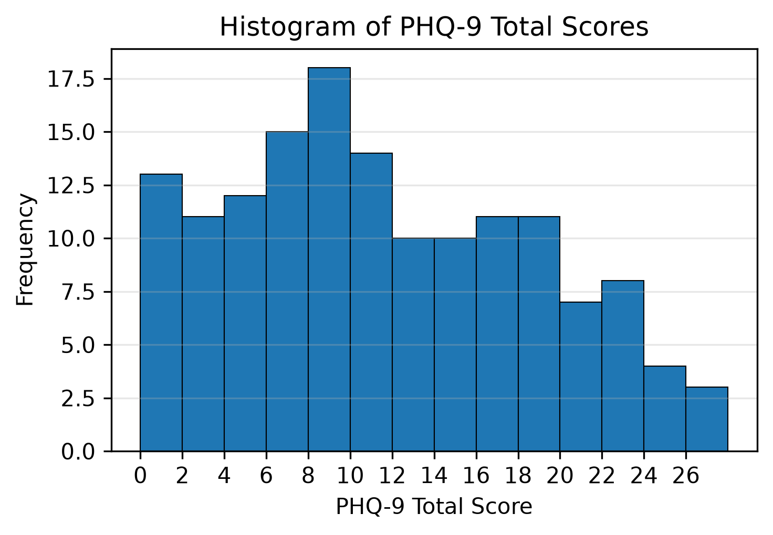
Figure 1. Distribution of PHQ-9 total scores (histogram, 2-point bins) across the 147 participants eligible under the scoring rule.
Figure 1 shows a broad distribution of scores across the whole 0-26 range, centred on 6-14; the distribution is close to symmetric and slightly flat-topped (skewness 0.296, excess kurtosis -0.918), so it is neither strongly skewed nor concentrated at one extreme. Approximately one in three students (50 of 147, 34.0%) scored 15 or above, the range that corresponds to moderately severe or severe symptoms.

4.4 Prevalence of Depressive Symptoms (Objectives 1 and 2)
Using the standard PHQ-9 cut-point, 78 of the 147 participants eligible under the missing-item rule (53.1%) scored 10 or above, indicating moderate-or-higher depressive symptoms; the 95% Wilson confidence interval for this prevalence was 45.0%-60.9%. The remaining 69 participants (46.9%) scored below the cut-point.
Table 7. Distribution of PHQ-9 severity categories and cut-point prevalence.
Severity band | n | %
Minimal | 30 | 20.4
Mild | 39 | 26.5
Moderate | 28 | 19.0
Moderately severe | 28 | 19.0
Severe | 22 | 15.0
At/above cut-point (≥10) | 78 | 53.1
PHQ-9 bands: Minimal 0-4, Mild 5-9, Moderate 10-14, Moderately severe 15-19, Severe 20-27. The shaded row aggregates Moderate + Moderately severe + Severe (score ≥ 10).
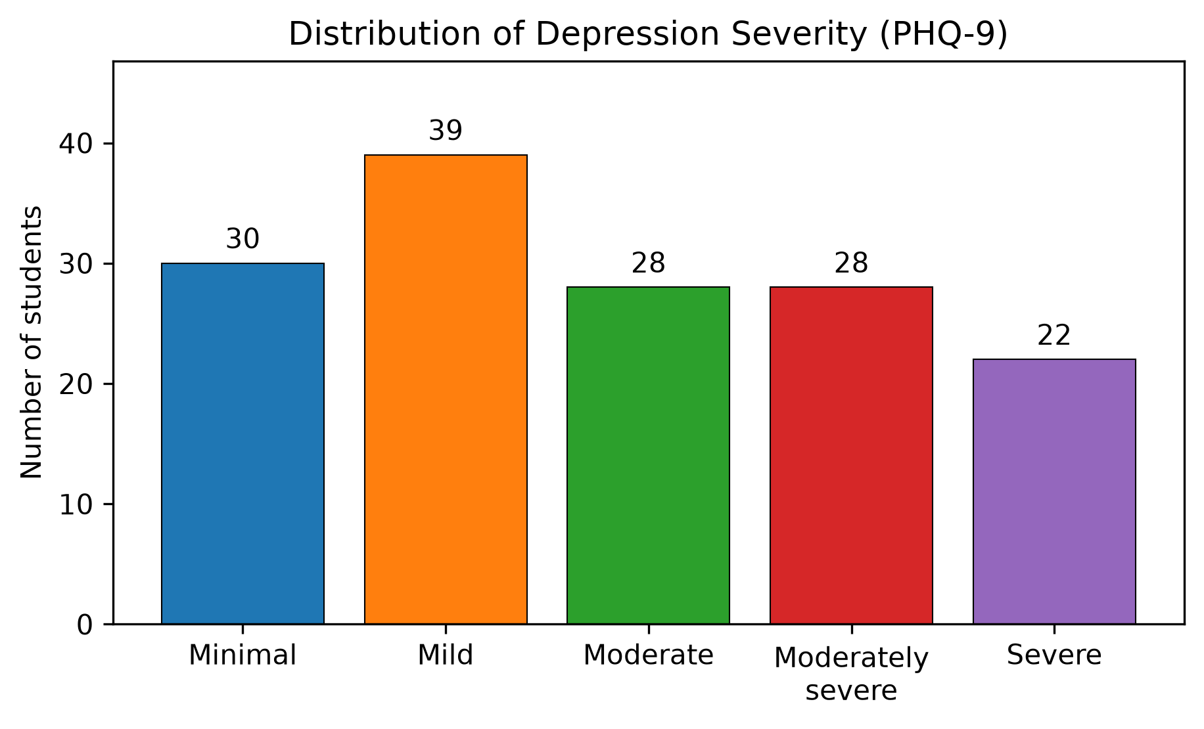
Figure 2. Distribution of PHQ-9 severity categories among the 147 participants eligible under the scoring rule.
Figure 2 shows that “Mild” was the most frequent category (39, 26.5%), followed by “Minimal” (30, 20.4%), “Moderate” (28, 19.0%), “Moderately severe” (28, 19.0%) and “Severe” (22, 15.0%). Altogether, 53.1% of the 147 eligible participants reached the moderate-or-higher threshold (score ≥ 10), which is the prevalence estimate reported for Objective 1.
Prevalence by academic stage (Table 8). The proportion scoring at or above the cut-point was highest in the 3rd stage (69.0%) and 2nd stage (64.7%), and lowest in the 1st stage (41.4%). Two different questions were tested, and neither showed a significant stage effect: a Kruskal-Wallis test of PHQ-9 score distributions across the six stages was not significant (H = 8.25, df = 5, p = 0.14), and a χ² test of case rates (PHQ-9 ≥ 10) by stage was also not significant (χ² = 6.05, df = 5, p = 0.30); the stage-wise point estimates are therefore not statistically reliable at the 0.05 level.
Table 8. Prevalence of PHQ-9 score ≥ 10 by academic stage.
Stage | n | Score ≥ 10 (k) | % | 95% Wilson CI (%)
1st | 29 | 12 | 41.4 | 25.51-59.26
2nd | 17 | 11 | 64.7 | 41.30-82.69
3rd | 29 | 20 | 69.0 | 50.77-82.72
4th | 23 | 11 | 47.8 | 29.24-67.04
5th | 33 | 16 | 48.5 | 32.50-64.78
6th | 16 | 8 | 50.0 | 28.00-72.00
CI = 95% Wilson confidence interval for the stage proportion. The third stage counts 29 records here rather than 31 in the sample descriptor (Table 4) because both records excluded under the missing-item scoring rule were third-stage students.
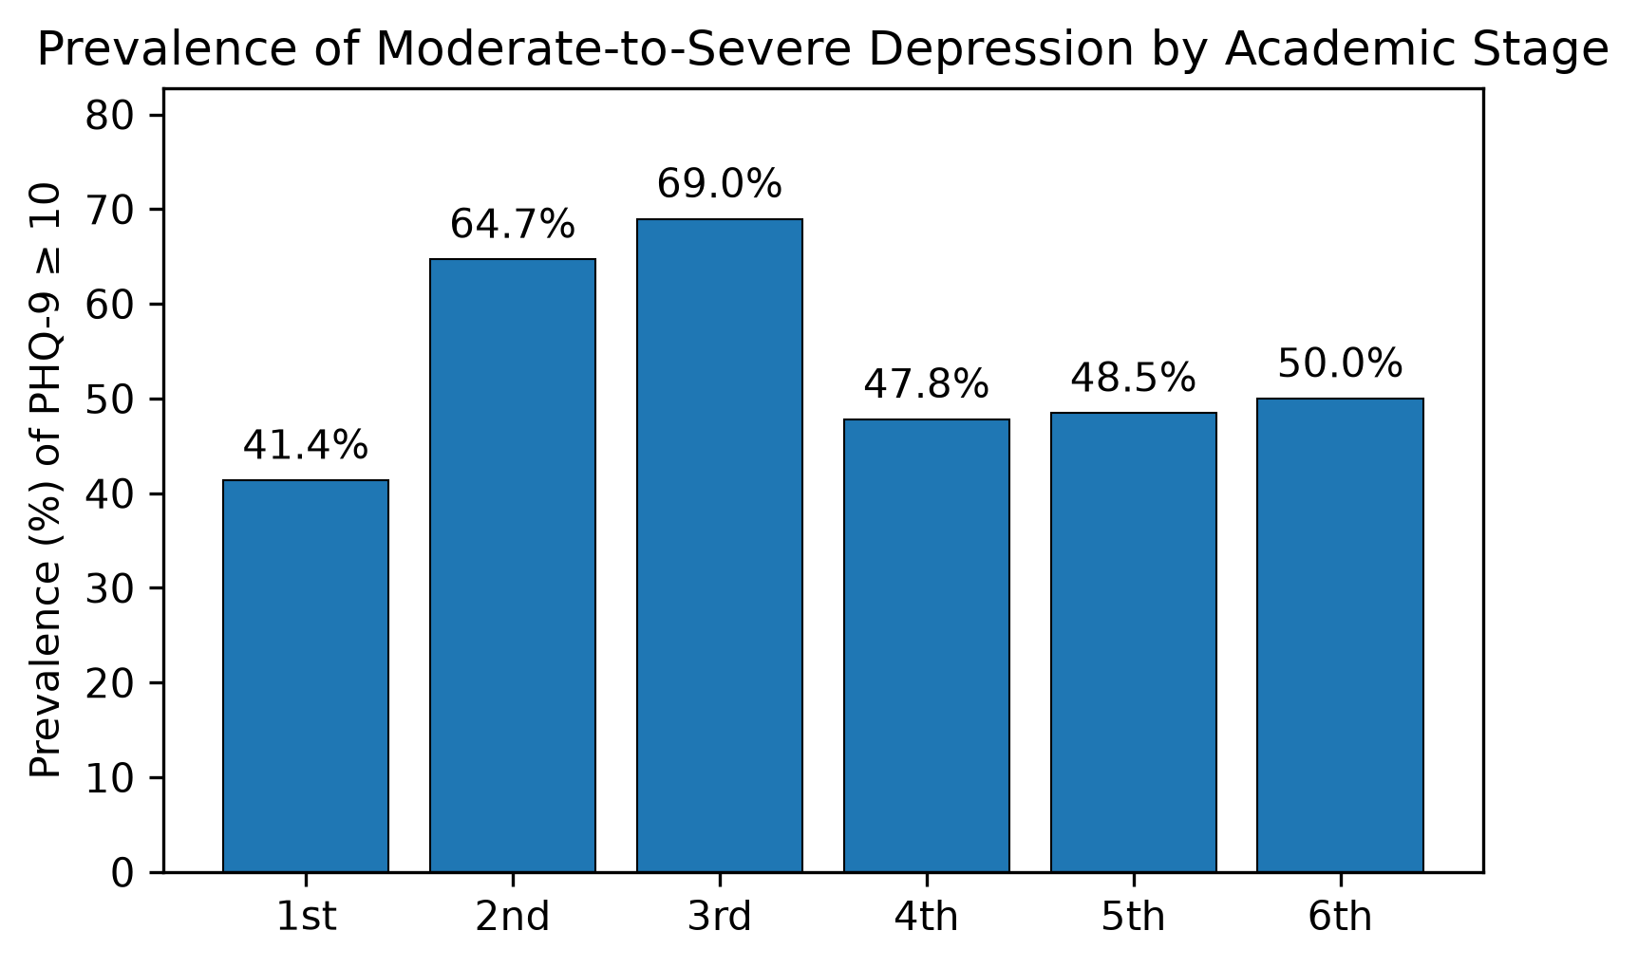
Figure 3. Prevalence of moderate-or-higher depressive symptoms (PHQ-9 ≥ 10) by academic stage.
The PHQ-9 self-harm item (item 9: “thoughts that you would be better off dead or of hurting yourself in some way”) was answered positively by 33 of 149 students (22.1% of all participants, 95% Wilson CI 16.2%-29.5%; among the 134 students who answered the item, 24.6%, 95% CI 18.1%-32.6%; the 15 missing responses were not counted as negative). This is a single-item signal only and does not diagnose a clinical condition.

4.5 Factors Associated with Depression (Objective 3)
Associations with depressive symptoms were examined in two steps: a univariate screen of each categorical covariate against PHQ-9 status (score ≥ 10), followed by a multivariable binary logistic regression. Univariate results (Table 9) were adjusted for the 14 comparisons using the Holm-Bonferroni procedure.
Table 9. Univariate association of categorical covariates with PHQ-9 score ≥ 10.
Covariate | n | Test | Statistic | p-value | OR (95% CI)
Gender | 147 | Fisher exact | – | p = 0.20 | 1.70 (0.81-3.57)
Marital | 147 | Fisher exact | – | p = 0.50 | 0.55 (0.13-2.27)
Residence | 147 | Pearson χ² | 0.62 (df=2) | p = 0.73
Income | 138 | Pearson χ² | 10.21 (df=2) | p = 0.006
Smoking | 146 | Monte Carlo χ² (200,000 permutations; 2 expected cells <5) | 0.13 (df=2) | p = 0.99
Chronic | 147 | Fisher exact | – | p = 0.014 | 4.19 (1.33-13.24)
Past psychiatric history | 142 | Pearson χ² | 1.25 (df=2) | p = 0.53
Sleep | 144 | Pearson χ² | 1.45 (df=3) | p = 0.69
Daily study hours | 146 | Pearson χ² | 3.24 (df=3) | p = 0.36
Support | 145 | Pearson χ² | 3.26 (df=2) | p = 0.20
Grade | 146 | Pearson χ² | 1.48 (df=4) | p = 0.83
Fail/repeat history | 147 | Monte Carlo χ² (200,000 permutations; 2 expected cells <5) | 1.61 (df=2) | p = 0.95
Performance | 147 | Pearson χ² | 2.25 (df=2) | p = 0.33
Mood-impact frequency | 147 | Pearson χ² | 41.83 (df=3) | p < 0.001
Tests: 2×2 comparisons use Fisher's exact test (no test statistic reported); larger tables use the Pearson χ² test, except for rows with two or more expected cells below 5 (smoking, fail/repeat history), which used a Monte Carlo permutation χ² test (200,000 replications). For reference, the Pearson χ² values of the 2×2 comparisons are: gender 1.97 (df=1), marital 0.71 (df=1) and chronic disease 6.75 (df=1).
Holm-Bonferroni correction over the 14 univariate comparisons: only mood-impact frequency remained significant (adjusted p < 0.001); income (adjusted p = 0.079) and chronic disease (adjusted p = 0.113) were significant before correction only; all other comparisons had adjusted p = 1.00. n = records with a non-missing value for the covariate.
After Holm-Bonferroni correction at a family-wise alpha of 0.05, only the association for mood-impact frequency (self-reported, p < 0.001) remained statistically significant; the Income and Chronic-disease associations, while nominally significant unadjusted, did not survive multiplicity correction.
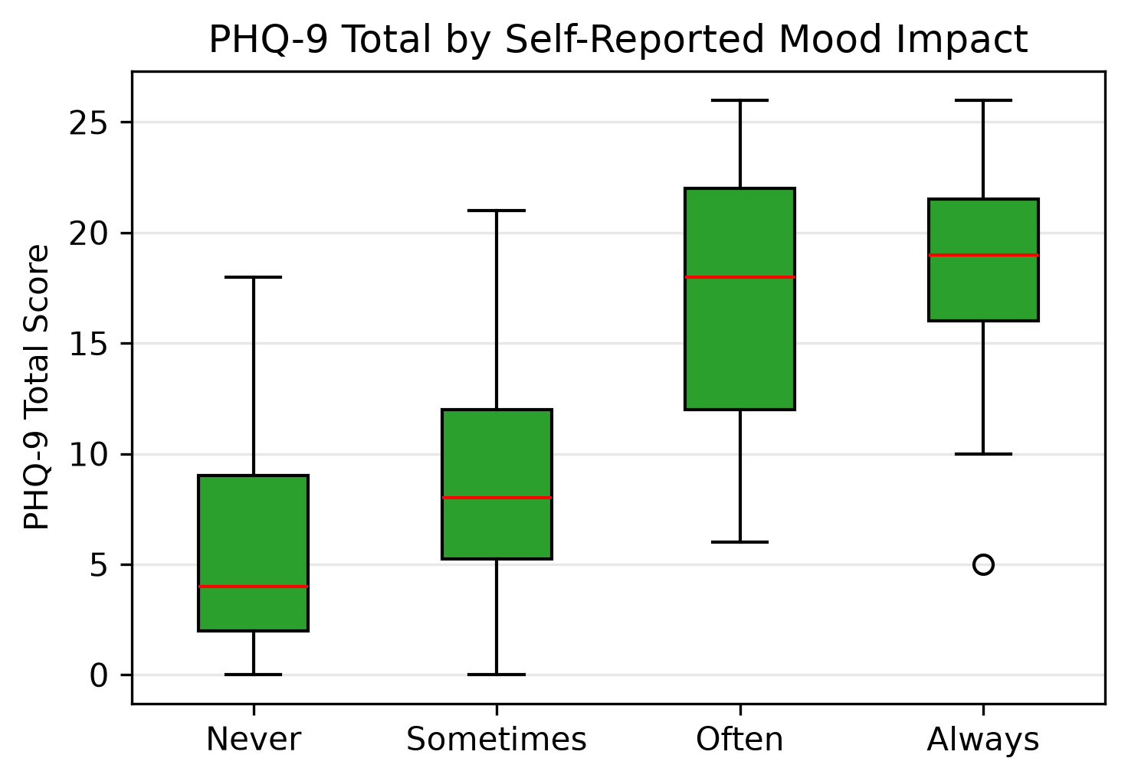
Figure 4. PHQ-9 total score by self-reported mood-impact frequency; Kruskal-Wallis H = 58.91, df = 3, p < 0.001.
Multivariable logistic regression. The primary model contained the covariates selected by the univariate screen (p < 0.10) that were not conceptually part of the outcome: income and chronic disease. The mood-impact item was excluded from the primary model for that reason and is reported separately below. The model converged with 138 observations and 74 events; with 3 fitted parameters this gives 24.7 events per parameter, above the conventional minimum of 10. Chronic disease was associated with the outcome (OR 5.38, 95% CI 1.48-19.56, p = 0.011), but this estimate rests on only three non-events among the 19 students with a chronic illness, and the variable did not survive the Holm-Bonferroni correction in the univariate screen (adjusted p = 0.113); it is therefore interpreted as an exploratory association rather than an established risk factor. Income was not significant (per-step OR 0.67, 95% CI 0.39-1.15, p = 0.14). Variance-inflation factors were 1.01 for both predictors, so no meaningful collinearity was present.
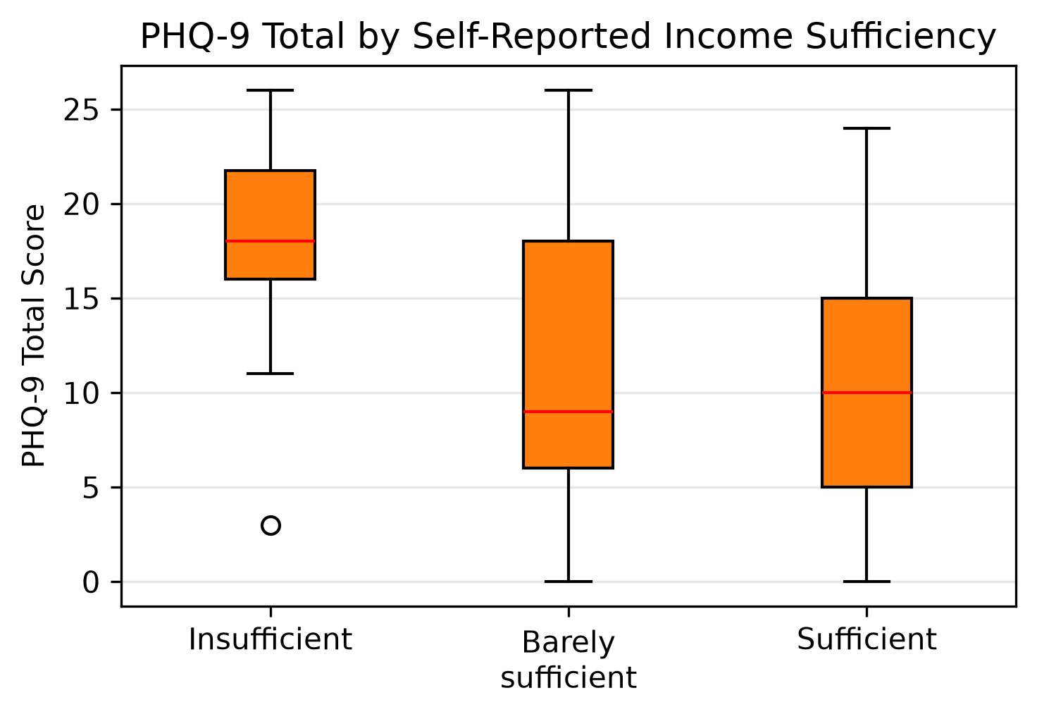
Figure 5. PHQ-9 total score by self-reported income sufficiency (n = 138; Kruskal-Wallis p = 0.003).
Table 10. Multivariable binary logistic regression for PHQ-9 score ≥ 10 (primary model: covariates selected by the univariate screen).
Predictor | OR | 95% CI | Wald p | VIF
Intercept | 0.76 | 0.47-1.21 | 0.25 | –
Income (ordinal) | 0.67 | 0.39-1.15 | 0.14 | 1.01
Chronic = Yes | 5.38 | 1.48-19.56 | 0.01 | 1.01
n = 138, events = 74 (24.7 events per fitted parameter). Income is entered as an ordinal predictor (0 = Insufficient, 1 = Barely sufficient, 2 = Sufficient, so the odds ratio is per one-step increase in income sufficiency) and chronic disease is binary (Yes=1, No=0). VIF = variance-inflation factor; both predictors had a VIF of 1.01, indicating no collinearity. OR = odds ratio per one-unit increase.
Ancillary model including the mood-impact item. Because the mood-impact item asks how often mood problems interfere with studying and daily living, it overlaps conceptually with the PHQ-9 outcome and does not belong in a risk model. For completeness the same dataset was refitted with the item added (Table 11). It was strongly associated with the outcome (OR 4.39, 95% CI 2.41-7.98, p < 0.001), which is best read as a consistency check rather than as an independent risk effect, because the item and the PHQ-9 measure the same construct. Adding it attenuated the chronic-disease estimate (OR 3.50, p = 0.082) and left income non-significant (OR 0.65, p = 0.19).
Table 11. Ancillary logistic model additionally including the mood-impact item.
Predictor | OR | 95% CI | Wald p
Intercept | 0.14 | 0.06-0.33 | < 0.001
Mood-impact frequency (ordinal 0-3) | 4.39 | 2.41-7.98 | < 0.001
Income (ordinal) | 0.65 | 0.35-1.23 | 0.19
Chronic = Yes | 3.50 | 0.85-14.36 | 0.08
Coding: mood-impact frequency 0 = Never, 1 = Sometimes, 2 = Often, 3 = Always; Income 0 = Insufficient, 1 = Barely sufficient, 2 = Sufficient; Chronic = Yes is the event-coded binary. Odds ratios represent a one-step increase on each ordinal scale. Both models include the same complete cases (n = 138, 74 events). This model is reported for completeness only: because the mood-impact item measures a construct closely related to the PHQ-9 outcome, its coefficient is a consistency check rather than an independent risk estimate.
Comparison of PHQ-9 scores across groups. Females (n = 107) and males (n = 40) of the 147 participants analysed did not differ significantly in PHQ-9 score (Mann-Whitney U = 2338.0, p = 0.39; rank-biserial r = -0.013, a negligible effect). Means and medians by academic stage, and the Kruskal-Wallis comparison across stages, are shown in Table 12.
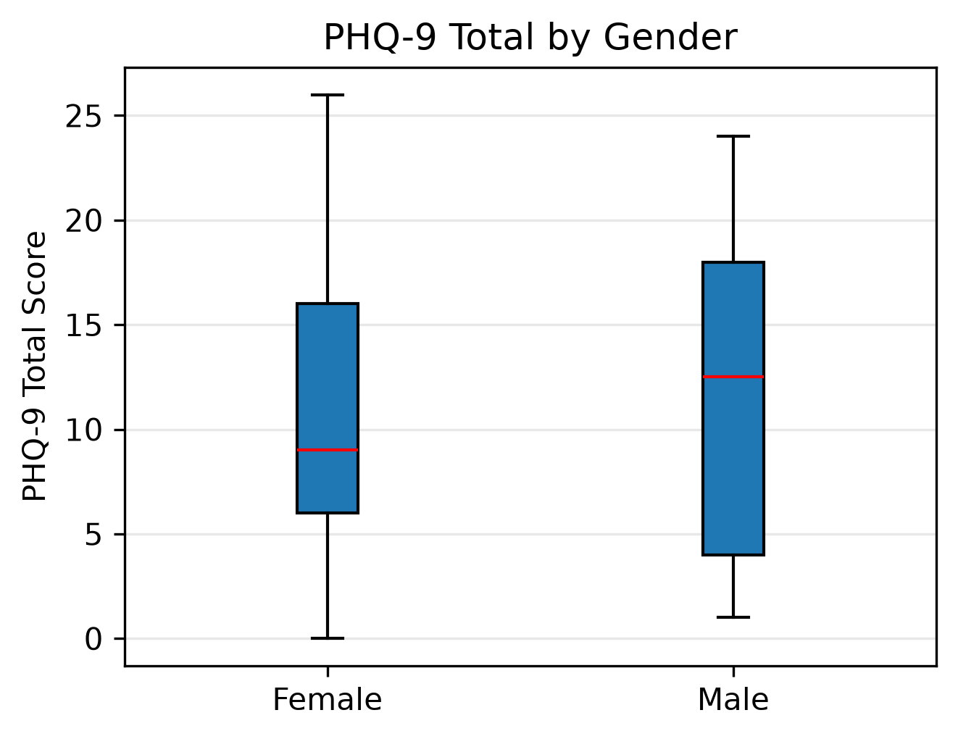
Figure 6. Box plot of PHQ-9 total score by sex (n = 147 analysed: 107 female, 40 male).
Table 12. PHQ-9 total score by academic stage, with the Kruskal-Wallis comparison reported in the text.
Stage | n | Mean | SD | Median | IQR
1st | 29 | 9.2 | 6.0 | 8 | 6.0-14.0
2nd | 17 | 13.6 | 7.8 | 15 | 6.0-20.0
3rd | 29 | 13.8 | 7.9 | 16 | 7.0-19.0
4th | 23 | 10.6 | 6.0 | 9 | 7.0-16.0
5th | 33 | 10.2 | 6.9 | 9 | 5.0-15.0
6th | 16 | 9.9 | 6.8 | 9.5 | 6.8-11.5
IQR = interquartile range (Q1-Q3).
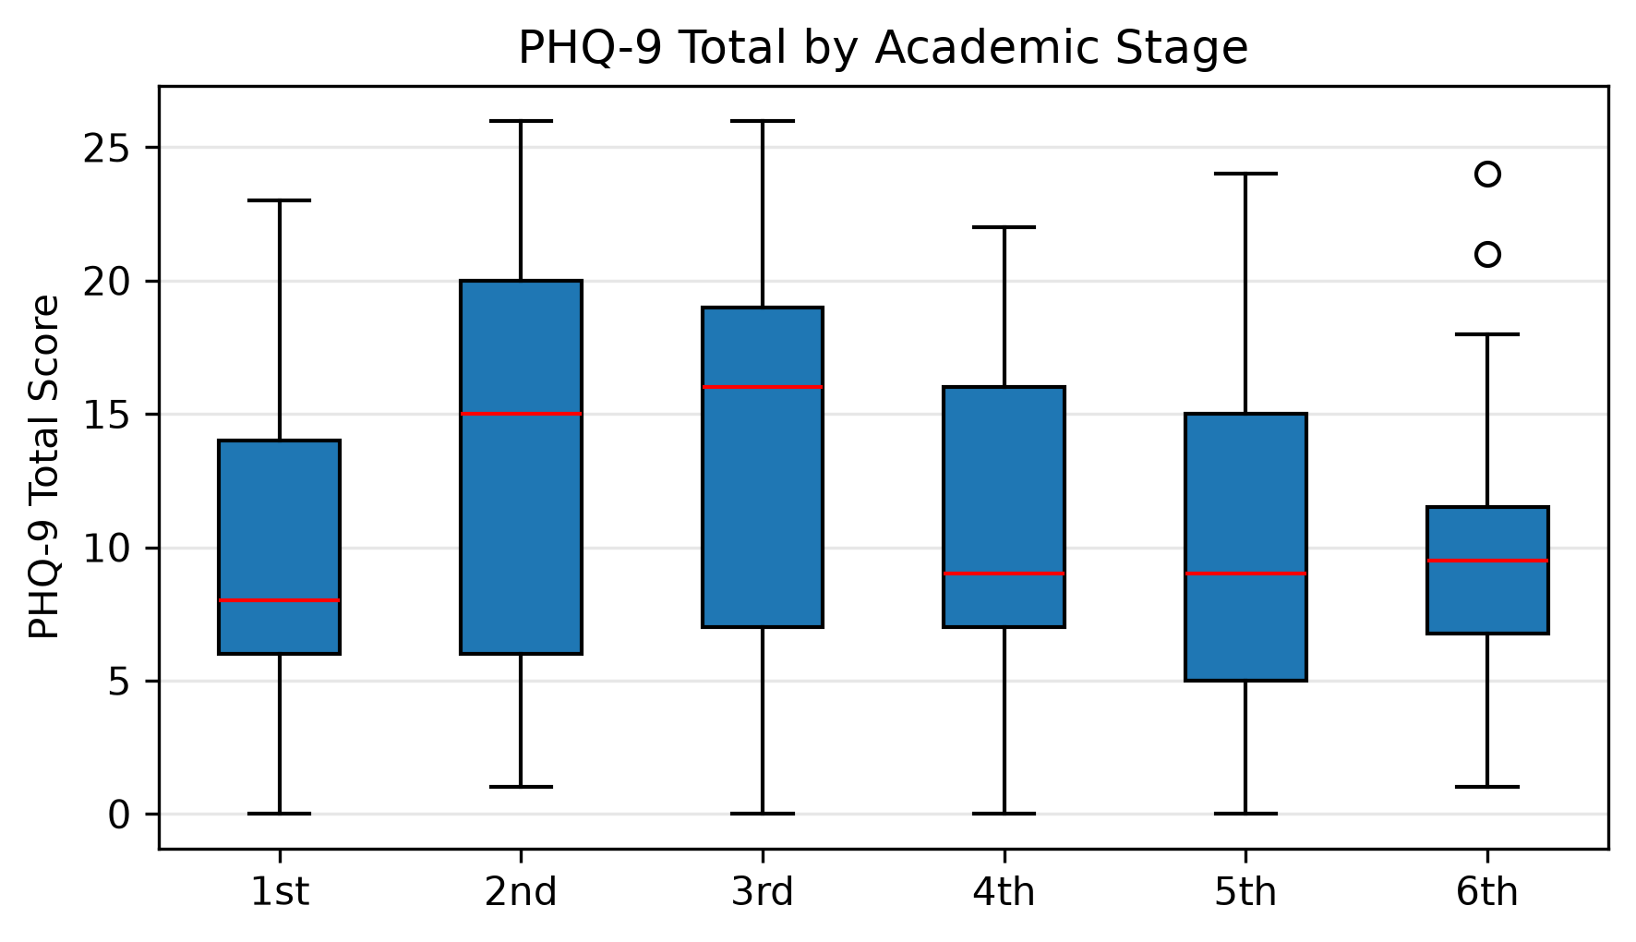
Figure 7. Box plot of PHQ-9 total score by academic stage.
Correlation with continuous and ordinal variables (Table 13). Self-reported mood-impact frequency and the difficulty item (PHQ_Difficulty) showed the strongest rank correlations with the PHQ-9 total (rho = 0.617 and 0.559, both p < 0.001), as expected given their conceptual proximity to depression. Age was not correlated with score (Pearson r = -0.032, p = 0.70; Spearman rho = -0.018, p = 0.83; n = 147). Sleep duration, study hours, grade and academic stage showed no meaningful correlation with the PHQ-9 total.
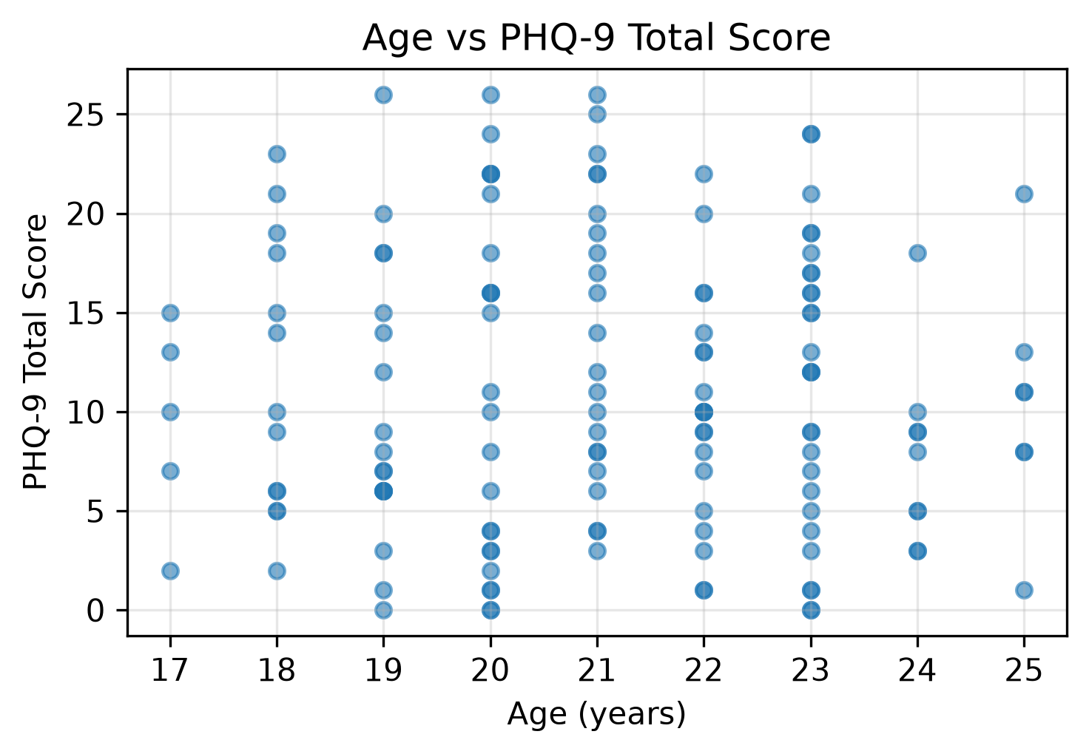
Figure 8. Scatter plot of age versus PHQ-9 total score (Pearson r = -0.032, p = 0.70, n = 147).
Table 13. Spearman rank correlation of ordinal variables with the PHQ-9 total score.
Variable | rho | p-value | n
Sleep duration (ordinal) | -0.127 | 0.13 | 144
Daily study hours (ordinal) | 0.041 | 0.63 | 146
Academic grade band (ordinal) | 0.052 | 0.54 | 146
Mood impact (ordinal) | 0.617 | < 0.001 | 147
PHQ difficulty item (ordinal) | 0.559 | < 0.001 | 145
Academic stage (ordinal) | -0.034 | 0.68 | 147
rho = Spearman correlation. n = pairs with both values non-missing. PHQ_Difficulty is the questionnaire item asking how much the symptoms interfered with daily activities.
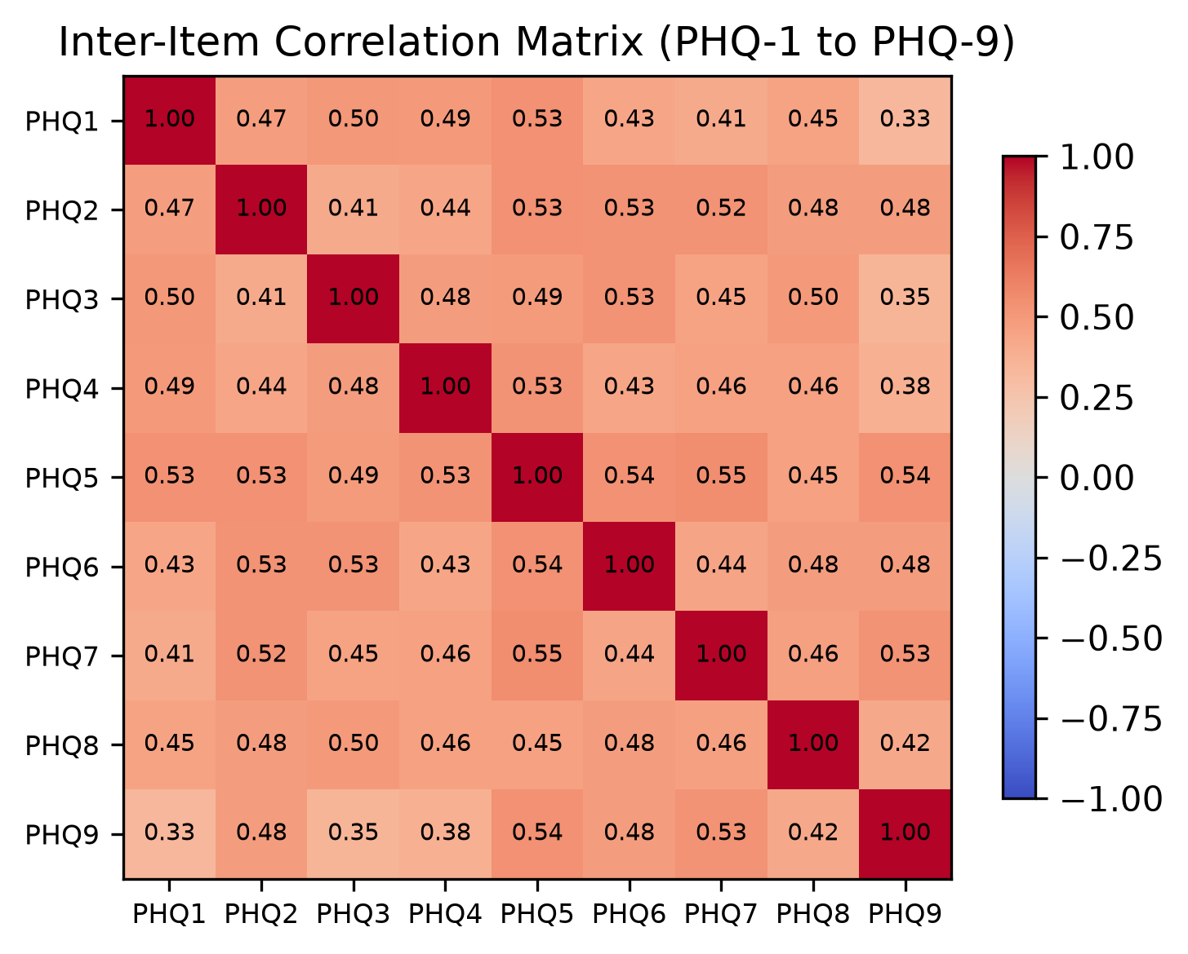
Figure 9. Inter-item correlation matrix (items 1 to 9).
The matrix shows moderate positive inter-item correlations, ranging from r = 0.33 to r = 0.55 across the 36 item pairs (computed on all available item responses, i.e. pairwise across the 149 records) (items 1-8: r = 0.41-0.55; the eight correlations involving item 9: r = 0.33-0.54). All pairwise correlations were positive and statistically significant (p < 0.001); the lowest value was between item 1 and item 9 (r = 0.33). Internal consistency of the nine items was good (Cronbach's alpha = 0.889). This pattern indicates that item 9 (thoughts of being better off dead or of self-harm) measures a related but distinct, less frequently endorsed symptom domain rather than a repetition of the other eight items.

4.6 Impact of Depression on Academic Performance (Objective 4)
The fourth objective asked whether depression is associated with academic performance. The performance variables (grade band, self-rated performance trend, and history of failing/repeating) were cross-tabulated against PHQ-9 status and compared across PHQ-9 score groups. No significant association was found (Table 14): grade band (Pearson χ², p = 0.83), performance trend (p = 0.33), and fail/repeat history (Monte Carlo χ², p = 0.95) were all non-significant. The Kruskal-Wallis comparison of PHQ-9 scores across grade bands was likewise non-significant (H = 0.80, df = 4, p = 0.94), and the Spearman correlation between grade and PHQ-9 score was weak (rho = 0.052, p = 0.54). These findings indicate that, in this sample, depressive symptoms were not statistically associated with academic performance; a cross-sectional design cannot establish that depression causes or does not affect performance, so this should be read as “no detectable association” rather than evidence of no effect.
Table 14. Association of academic-performance variables with PHQ-9 status (≥ 10).
Variable | n | Test | Chi-square | df | p-value
Grade band | 146 | Pearson χ² | 1.48 | 4 | 0.83
Performance trend | 147 | Pearson χ² | 2.25 | 2 | 0.33
Fail/repeat history | 147 | Monte Carlo χ² (200,000 permutations; 2 expected cells <5) | 1.61 | 2 | 0.95
Fail/repeat history: Monte Carlo test (see Table 9 footnote). Grade: Pearson χ², all expected cells ≥ 5.
Table 15. Kruskal-Wallis comparison of PHQ-9 scores across academic-performance groups.
Group variable | H | df | p-value
Grade band | 0.80 | 4 | 0.94
Performance trend | 3.52 | 2 | 0.17
H = Kruskal-Wallis statistic; groups are the ordered performance categories.

4.7 Limitations of the Analysis
Several caveats affect the interpretation of these results. First, the convenience sampling design limits generalisability. Second, the cross-sectional, single-time-point design precludes causal inference: the significant mood-impact association in particular reflects a co-occurring self-report rather than a risk factor. Third, the chronic-disease estimate in the primary model rests on only three non-events and did not survive multiplicity correction in the univariate screen, so it is reported as an exploratory association only. Fourth, one record with an implausible age (62 years, against an observed range of 17-25 years) was excluded in its entirety as a data-entry error, so all reported statistics use the remaining 149 participants. Fifth, the analysis sample for PHQ-9 scores is 147 rather than 149: the 21 records with a single missing item were completed by mean imputation in line with the documented scoring rule (no cut-point classification changed), and the 2 records with two or more missing items were excluded from score-based analyses; the complete-case estimate (50.8%) is close to the primary figure.

CHAPTER FIVE: DISCUSSION
The most important finding of this study is the high prevalence of moderate-or-higher depressive symptoms: 53.1% of the 147 participants eligible under the missing-item rule (95% CI 45.0-60.9) scored 10 or higher on the PHQ-9, and a further 26.5% scored in the mild band, so that nearly four in five participants (79.6%) showed at least mild symptoms. The mean total score of 11.12 (SD 7.03) sits just above the moderate threshold, and 22.1% of all participants (24.6% of those who answered the item) endorsed the self-harm item. These figures indicate a substantial level of need among medical students at our institution and provide the benchmark against which the current counselling provision should be assessed.
Compared with global meta-analytic estimates, the prevalence in our sample is notably higher. The pooled prevalence of depression or depressive symptoms reported by Rotenstein and colleagues was 27.2% (95% CI 24.7-29.9), and Puthran and colleagues estimated 28.0% (95% CI 24.2-32.1) [2-3]. Part of this difference is methodological: the meta-analytic pools mix many instruments and definitions (from 'any depressive symptom' to probable major depression), whereas our estimate is a single, uniform cut-off (PHQ-9 of 10 or higher, representing moderate-or-higher symptoms). The remainder is most likely attributable to the setting: a single college, a convenience sample of respondents, and the current academic and social environment; the female majority of the sample (72.5%) is unlikely to be the explanation, because no sex difference in PHQ-9 scores was detected in this sample (p = 0.39). Within the Middle East, by contrast, our result is in line with previous reports: 65% in Egyptian medical students [7], a mean of 51.5% across 18 Saudi Arabian studies [8], 45.9% among Iraqi healthcare students on the HADS [9], and 57.9% mild-to-moderate symptoms in the most recent survey at our own college [6], although that figure uses a lower symptom threshold than the ≥ 10 cut-off applied here. Puthran's observation that Middle Eastern students are more likely to be depressed, although not statistically significant [2], is directionally consistent with the regional data. The recent nationwide Iraqi survey is also relevant to interpretation: severe depressive symptoms were reported by 20.4% of 3,107 adults, and levels were higher in the middle and southern governorates and in younger adults [13]. Although that survey used a different sampling frame and reported a different severity threshold, it shows that the mental-health burden we observed in one medical college is part of a wider national pattern rather than an isolated finding.
Three findings merit particular comment. First, the mood-impact item was strongly associated with PHQ-9 status (OR 4.39, 95% CI 2.41-7.98, p < 0.001; Spearman rho 0.617), but this reflects overlap with the outcome rather than an independent effect: the item asks how often mood problems interfere with studying and daily living, so it is not a plausible risk factor for the PHQ-9 total. It was therefore kept out of the primary model and reported separately. Second, chronic disease was nominally associated unadjusted (OR 4.19, p = 0.014; Holm-adjusted p = 0.113) and was associated in the primary model (OR 5.38, p = 0.011) when the mood item was removed, suggesting an association between chronic physical illness and depressive symptoms that is plausible but remains exploratory: with only three non-events among the 19 participants with chronic disease, the confidence interval (1.48-19.56) is wide, and this result is a hypothesis to test in larger cohorts rather than proof of an independent risk factor. Third, family income was associated unadjusted (p = 0.006) but did not survive multiplicity correction; financial strain is a plausible contributor, and further studies with larger samples are needed to resolve it. The absence of a sex difference (Mann-Whitney p = 0.39) despite a 72.5% female sample is probably a reflection of limited statistical power in the small male subgroup (n = 40) rather than evidence of parity. The lack of a stage effect (Kruskal-Wallis p = 0.14 on PHQ-9 scores; χ² p = 0.30 on case rates), with the highest point estimate in the third stage (69.0%), contrasts with the 'first year highest' pattern of the global meta-analyses [2] and with the earlier data from our own college [6]; the difference is likely driven by sample size and by the specific composition of stages in this convenience sample. Variance-inflation factors were near 1 in both models (1.01 in the primary model and 1.02-1.07 in the ancillary model), so collinearity did not distort the odds ratios; the uncertainty around the chronic-disease estimate comes from having only three non-events rather than from collinearity, and it should be read as exploratory.
The null finding for academic performance is the result most at odds with the literature. Across 45 studies, depressive symptoms showed a negative association with grades, examinations and licensing outcomes in the large majority of articles [4], and our own data show no significant association between PHQ-9 status and grade band, self-rated performance trend or history of failing or repeating (p = 0.83 for grade band, 0.33 for performance trend and 0.95 for fail/repeat history; all clearly non-significant). Several explanations are possible. The grade variable is coarse (banded, self-reported) and the grade bands were fairly evenly spread (Medium 24.2%, Good 30.2%, Very good 25.5%), which restricts the range and can mask a true effect. Students who chose to complete the study may be those coping better with their studies, and the cross-sectional design cannot capture performance over time. We therefore do not read the null result as proof that depression does not affect grades; it is an estimate from a single-time-point sample of one institution, and a longitudinal study with objective GPA data is the appropriate follow-up.
The proportion endorsing the self-harm item (22.1%) exceeds the global pooled estimate of suicidal ideation of 11.1% [3]. Item 9 is a single screening question, not a diagnosis, and its 95% confidence interval (16.2-29.5%) is wide. The 22.1% reported here reflects endorsement of a single screening item at any frequency over the past two weeks, a broader measure than the suicidal-ideation definitions pooled by Rotenstein; the two estimates are not strictly comparable, and the difference should be read as an upper-bound signal rather than a precise excess. Nevertheless, combined with the global observation that only 15.7% of students who screened positive sought psychiatric treatment [3], it argues for a standing safeguard protocol. Because this study was anonymous, individual referral is not possible from its data; a standing protocol should therefore (a) provide information on confidential college counselling and mental-health resources to every participant at the end of screening, and (b) establish an identifiable opt-in referral pathway so that students screening at 10 or higher, and every student endorsing item 9, can be offered confidential support promptly.
The limitations of the study have been stated in Chapter Four (Section 4.7) and are summarised here: a convenience sample from a single college, a cross-sectional single-time-point design, self-reported (rather than clinically diagnosed) depressive symptoms, exclusion of the two records with two or more missing PHQ-9 items from score-based analyses (the 21 records with a single missing item were scored by mean imputation, and none changed the cut-point classification), and the absence of objective academic records. None of these limitations invalidates the central finding, a high prevalence of depressive symptoms in our population, but they do temper the strength of the factor and academic-performance conclusions. One record (a self-reported age of 62 years, implausible for an undergraduate sample) was excluded in its entirety as a data-entry error; all analyses therefore use the remaining 149 participants, and this cleaning step does not change any reported prevalence estimate.
This study documents a high burden of depressive symptoms among medical students at the University of Baghdad. No single characteristic emerged as a robust independent predictor in this sample, so the case for a structured screening-and-referral response rests on the size of the burden itself and on the high proportion of students endorsing the self-harm item, rather than on a specific risk profile.

CHAPTER SIX: CONCLUSIONS AND RECOMMENDATIONS

Conclusions
1. The prevalence of moderate-or-higher depressive symptoms (PHQ-9 of 10 or higher) among medical students at the College of Medicine, University of Baghdad, is high: 53.1% (95% CI 45.0-60.9), with a further 26.5% in the mild band.
2. The primary multivariable model (covariates selected by the univariate screen: income and chronic disease) identified no robust independent predictor: chronic physical illness showed an exploratory association (OR 5.38, 95% CI 1.48-19.56, p = 0.011) that did not survive multiplicity correction and rested on only three non-events, and income was not significant. The mood-impact item was strongly associated with PHQ-9 status (OR 4.39, 95% CI 2.41-7.98, p < 0.001) but measures essentially the same construct as the outcome and is not an independent risk factor.
3. No significant association between PHQ-9 status and academic performance was found in this sample; this null result should be interpreted cautiously given the coarse grade measure and the cross-sectional design.
4. Point prevalence of PHQ-9 positive screening results was highest in the second and third academic stages, although the stage differences were not statistically significant (Kruskal-Wallis p = 0.14 for scores; χ² p = 0.30 for case rates); no significant sex difference was detected (p = 0.39).
5. 22.1% of all students (33/149; 24.6% of the 134 who answered the item) endorsed the PHQ-9 self-harm item, a signal that exceeds global estimates of suicidal ideation, although the two measures differ in instrument and definition, and that warrants a standing safeguard protocol.

Recommendations
1. Introduce a confidential, college-based mental-health and counselling service, with a defined confidential, opt-in referral pathway for students screening 10 or higher on the PHQ-9 and for any student endorsing the self-harm item (individual identification was not possible in this anonymous study).
2. Institute routine, repeated PHQ-9 screening across all academic stages; the highest point estimates were observed in the second and third stages, but this difference was not statistically significant, so screening should not be limited to particular stages.
3. Offer structured peer-support and mentoring schemes and review the academic workload, which the literature identifies as a modifiable stressor (Section 2.4).
4. Provide targeted support for students with chronic physical disease, an association that was exploratory in this study (it did not survive multiplicity correction and rested on a small number of non-events).
5. Run awareness campaigns for students, teaching staff and families, addressing the stigma and other barriers to help-seeking described in the literature (Sections 1.2 and 2.1), which were not measured in this study.
6. Repeat the study with a random sampling frame, objective GPA data and a longitudinal follow-up, so that the association between depression and academic performance can be established across the whole curriculum.

REFERENCES
1. World Health Organization. Depressive disorder (depression): fact sheet. Updated 11 September 2026. Geneva: World Health Organization. https://www.who.int/news-room/fact-sheets/detail/depression (accessed 15 October 2026).
2. Puthran R, Zhang MWB, Tam WW, Ho RC. Prevalence of depression amongst medical students: a meta-analysis. Med Educ. 2016;50(4):456-68.
3. Rotenstein LS, Ramos MA, Torre M, Segal JB, Peluso MJ, Guille C, et al. Prevalence of depression, depressive symptoms, and suicidal ideation among medical students: a systematic review and meta-analysis. JAMA. 2016;316(21):2214-36.
4. Rios Andrade R, Peralta Ramirez AA, Trujillo Lopez S. Psychosocial factors associated with academic performance in medical students: a systematic review. BMC Med Educ. 2026;26:451. doi:10.1186/s12909-026-08742-6.
5. Erschens R, Keifenheim KE, Herrmann-Werner A, et al. Professional burnout among medical students: systematic literature review and meta-analysis. Med Teach. 2019;41(2):172-83. doi:10.1080/0142159X.2018.1457213.
6. Jaber ZA, Salman RT, Abid Al Wahab DY, Habib MA, Hussein IA. Assessment of the depression level among medical students at University of Baghdad, College of Medicine. Al-Kindy Col Med J. 2021;17(3):175-9.
7. Fawzy M, Hamed SA. Prevalence of psychological stress, depression and anxiety among medical students in Egypt. Psychiatry Res. 2017;255:186-94.
8. AlJaber MI. The prevalence and associated factors of depression among medical students of Saudi Arabia: a systematic review. J Fam Med Prim Care. 2020;9(6):2608-14.
9. Kathem SH, Al-Jumail AA, Noor-Aldeen M, Najah N, Ali Khalid D. Measuring depression and anxiety prevalence among Iraqi healthcare college students using Hospital Anxiety and Depression Scale. Pharmacy Pract (Granada). 2021;19(2):2303.
10. Negeri ZF, Levis B, Sun Y, He C, Krishnan A, Wu Y, et al. Accuracy of the Patient Health Questionnaire-9 for screening to detect major depression: updated systematic review and individual participant data meta-analysis. BMJ. 2021;375:n2183.
11. Kroenke K, Spitzer RL, Williams JB. The PHQ-9: validity of a brief depression severity measure. J Gen Intern Med. 2001;16(9):606-13. doi:10.1046/j.1525-1497.2001.016009606.x.
12. AlHadi AN, AlAteeq DA, Al-Sharif E, Bawazeer HM, Alanazi H, AlShomrani AT, et al. An Arabic translation, reliability, and validation of Patient Health Questionnaire in a Saudi sample. Ann Gen Psychiatry. 2017;16:32. doi:10.1186/s12991-017-0155-1.
13. Ahmed DR, Kakamad KK, Al-Taie RH, et al. Prevalence of depression and generalised anxiety disorders in Iraq: a nationwide study. Middle East Curr Psychiatry. 2026;33:4. doi:10.1186/s43045-025-00606-x.
14. Radi UK, Abdul-Hussein AH, Hussein UA-R. Prevalence of depression and the use of antidepressants among Iraqi medical students. Int J Med Toxicol Leg Med. 2024;27(2S):181-90.

Appendix A. Variable Dictionary
The 30 variables in the dataset, their types and coding. Numeric types: continuous (C), ordinal (O), nominal (N).
Table A1. Variable dictionary (30 variables).
Variable | Measure | Type | Coding / values
ID | Identifier | N (code) | Participant identifier 1-150
Consent | Consent to participate | N | Online consent statement accepted before proceeding
Age | Age in years | C | Years; 17-25 observed (one implausible value excluded as a data-entry error)
Gender | Biological sex | N | Female / Male
Stage | Academic stage | O | 1st-6th
Marital | Marital status | N | Single / Engaged-Married
Residence | Residence type | N | With family / Dormitory / Private
Income | Income sufficiency | O | Insufficient / Barely / Sufficient
Smoking | Smoking status | O | Never / Ex-smoker / Current
Chronic | Chronic illness | N | Yes / No
PsychHx | Past psychiatric history | N | Yes / No / Prefer not to say
Sleep | Sleep duration | O | <5 / 5-6 / 7-8 / >8 h
StudyHours | Daily study hours | O | <2 / 2-4 / 5-6 / >6 h
Support | Perceived support | O | No / Sometimes / Yes
Grade | Recent grade band | O | Pass / Medium / Good / Very good / Excellent
FailHx | Fail/repeat history | N | No / Second attempt / Repeated a year
Performance | Performance trend | O | Better / Same / Worse
MoodAffect | Mood impact frequency | O | Never / Sometimes / Often / Always
PHQ1-9 | PHQ-9 items | O (0-3) | 0-3 each; item 9 = self-harm
PHQ_Difficulty | Interference item | O (0-3) | 0-3
PHQ_Total | PHQ-9 total score | C (0-27) | Sum of the nine items (one missing item imputed with the mean of the answered items; records with 2 or more missing items excluded)
PHQ_Severity | Derived severity band | O | Minimal/Mild/Moderate/Mod-severe/Severe

Appendix B. Statistical Methods and Assumptions
A summary of the statistical tests used, the question each addresses and the key assumptions, so that the analysis can be followed and reproduced. The analysis syntax used to reproduce these analyses is available from the authors on request.
Table B1. Statistical tests and their assumptions.
Test | Purpose | Key assumption | Note
Frequencies & % | Descriptive, categorical | None
Mean, SD, Median, IQR | Descriptive, continuous/ordinal | Appropriate measure type
Kolmogorov-Smirnov | Normality of PHQ-9 total | Empirical vs N(mean,SD) | Lilliefors-corrected because the parameters are estimated from the sample
Mann-Whitney U | Two independent groups (sex) | No normality required
Kruskal-Wallis | ≥3 independent groups | No normality required
Chi-square / Fisher exact | Association, categorical x binary | Expected cell counts | Fisher for 2×2 tables with small cells; Monte Carlo permutation χ² (200,000 replications) when 2 or more expected cells are below 5
Pearson / Spearman | Bivariate correlation | Linear (Pearson); monotone (Spearman)
Binary logistic regression | Multivariable prediction | Independence; adequate EPV | EPV = 24.7 in primary model
Holm-Bonferroni | Multiplicity over 14 univariate tests | Family-wise alpha 0.05

Appendix C. Study Questionnaire
The bilingual Arabic-English questionnaire administered in this study (section headings in Arabic and the PHQ-9 scale as presented to participants). Reproduced exactly as administered.
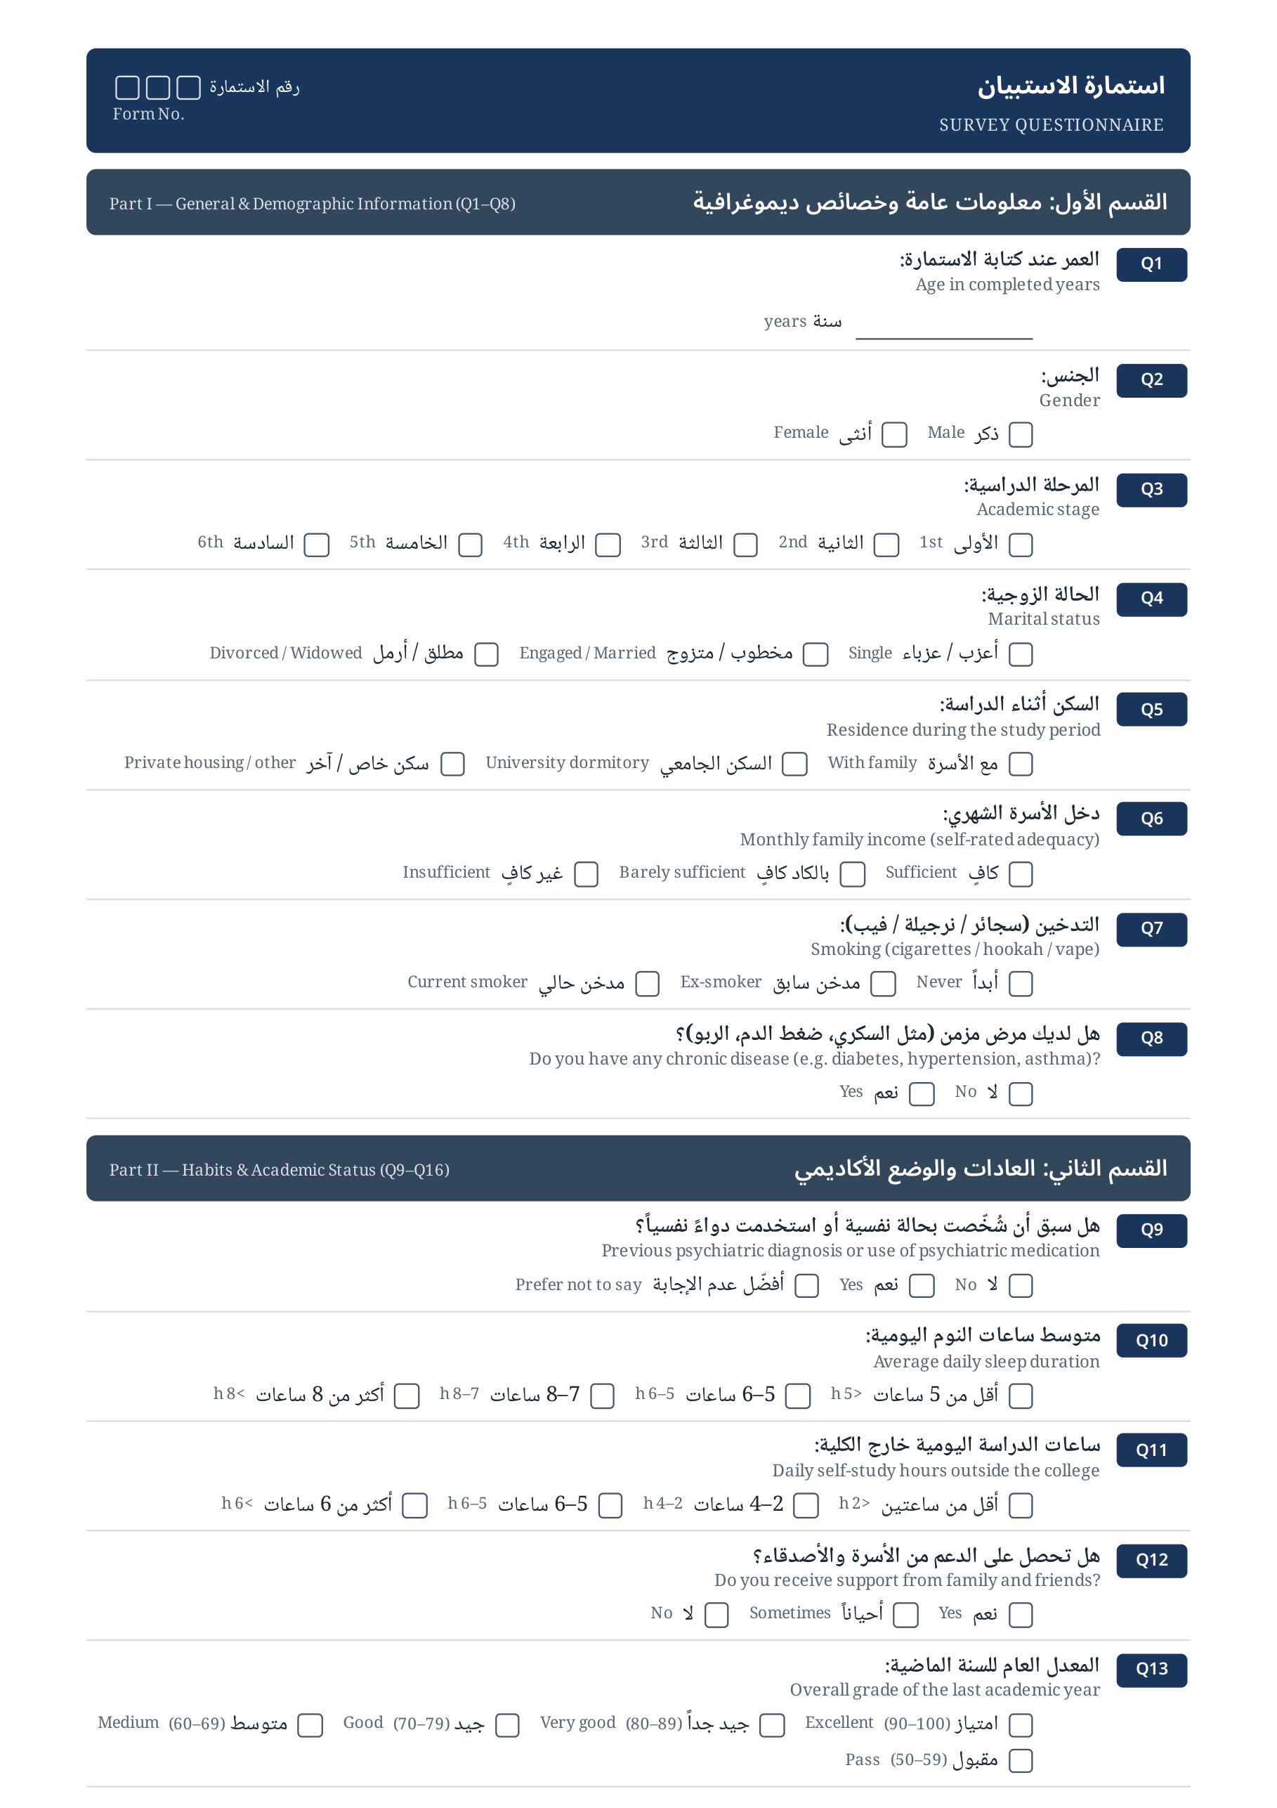
Study questionnaire, page 1: general and demographic information and habits and academic status (bilingual Arabic-English).
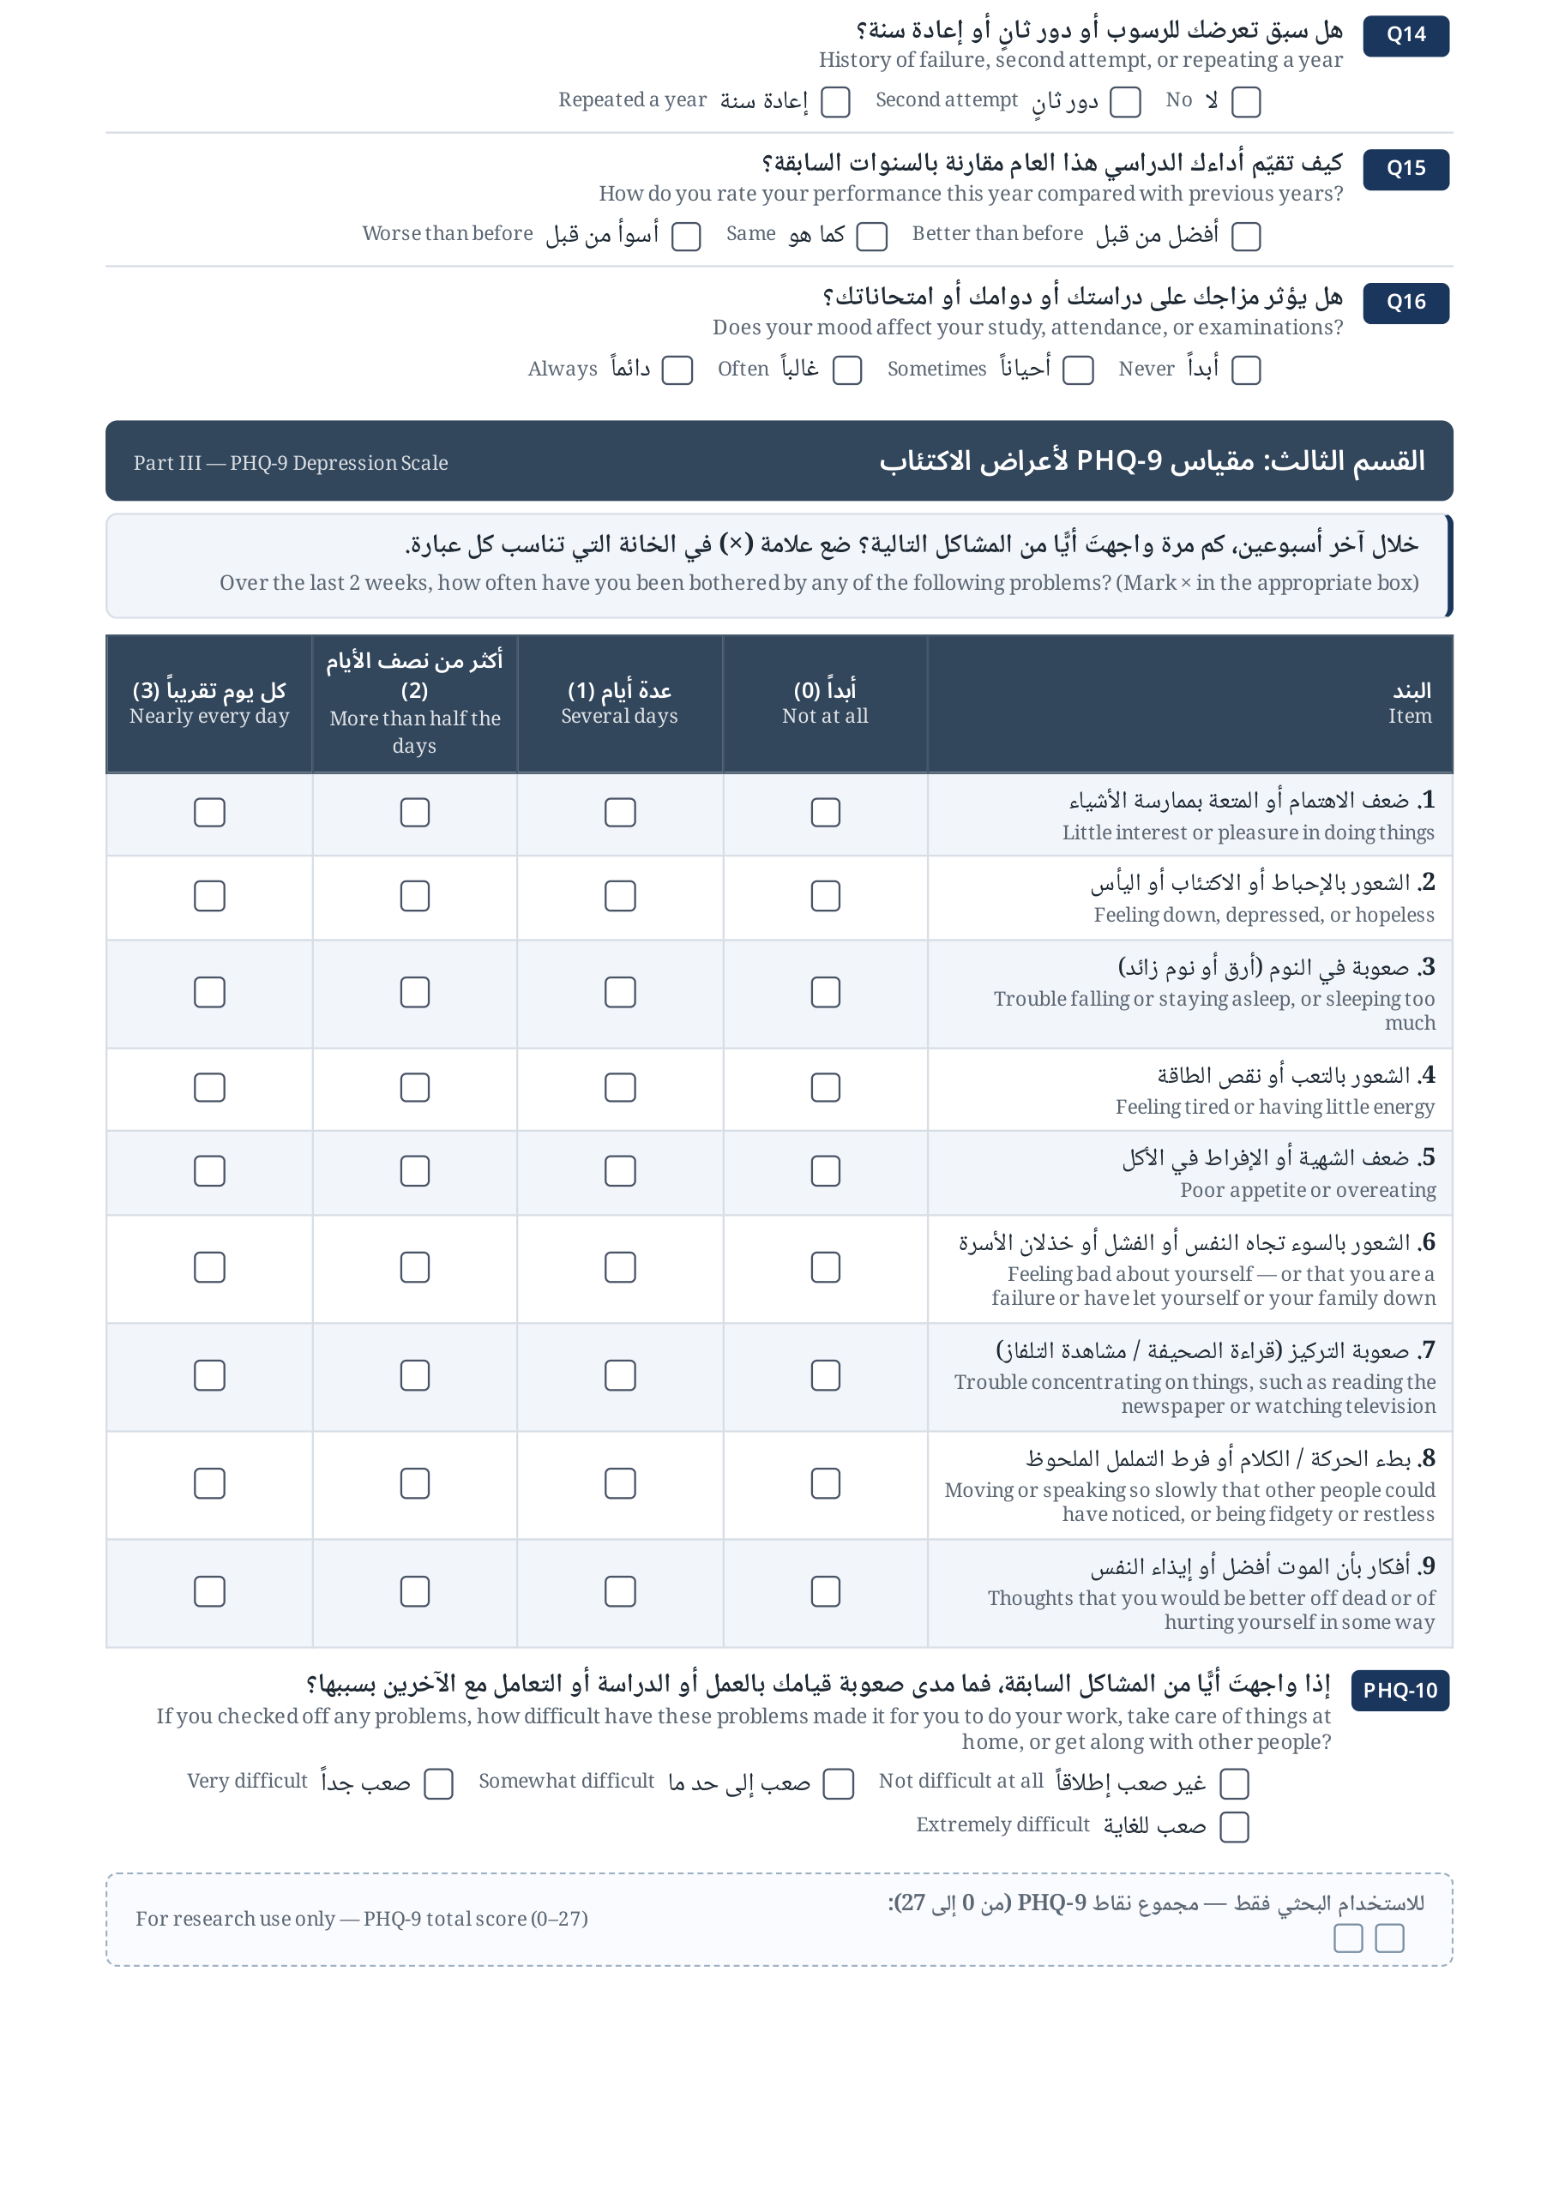
Study questionnaire, page 2: the PHQ-9 scale as presented to participants (bilingual Arabic-English).

